**Conversation Guide: Digital Health Modernization Discovery Research - Caregiver Group**

**Bold text identify the moderator’s questions.**

*Text in italics are Jen’s observations and interpretations of the participant.*

[Text in brackets are interpretations in participants’ direct quote.]

**Background (5 minutes)**

To get started, I’d like to get a little background information about you, and your experience with the VA.

1. **Can you tell me a little bit about yourself?**

I am in Brighton Michigan.

I am retired but in my free time I help restore and fly old Vietnam helicopters at air shows and Veteran events. That’s what I do besides family stuff.

I travel a bit and I do the snowbird stuff. That’s about it.

**Which branch of the military were you in**:

Army.

1. **When did you leave**:

In 1972.

1. **What do you receive for benefits from the VA?**

They are my primary care facility.

I am 50 percent disabled.

Basically you know just old guy stuff. A little bit of kidney stones problems, slightly elevated blood pressure, sleep apnea. That’s about it. Well glasses but that is low on the totem pole.

It is a pretty regular thing. I am obligated to stay on top of my health if I want to retain my pilots license, which is outside of the VA. There is a medical certificate I need to have so I just coordinate all my care at the VA with the flight physician. So just try to keep on top of it. Somethings annually and others semi-annually.

**When you coordinate things for your pilots license, how does that work in terms of record sharing:**

Yeah, once a year I have to get a medical, what’s called a airmen medical certificate. The FFA of course being another federal agency wants all of the information they can get their hands on. So usually I have to data dump history, and either send it electronically or put it on a CD and take it to the flight physician who is a civilian practitioner.

**For the data dump which system do you use:**

Usually I do it March so at this time I probably have a brain dump on that.

But I believe I just go under My Health Vet and pull the records down from there.

If the appointments I have at the VA I get it coordinated with the urologists, sleep clinic, if I can get them all scheduled in late February, early March, I can typically get them to download it for me. They may or may not give me a CD.

As my fall back I have always been able to download it off of Health Vet and get that burned on a CD or memory stick and give to the flight physician and he downloads it from there.

It is a big step from what we had to do before. We basically had to got to the records and documents little office at the VA hospital and fill out forms to get forms. Give them your parameters and then come back in two weeks for the papers.

That has come along way. It probably could be easier but for once a year its not a big deal.

1. **Does you have any family members they claim as dependents?**

No.

1. **Do you manage any of your health care tasks online?**

When I have I might have to schedule an appointment. I have been trying to do that more often. Especially when trying to manipulate these dates to fall into the first week of March. Because the end of March is my brick wall. If my flight medical isn’t done at by the end of March I can’t fly.

Depends on which clinic I need to see I will try to start to schedule. Even though they will say see you next year, and notify me two months before, but it has fallen through the cracks too many times.

So for urology and sleep clinic I try to make my appointment 6 months in advance, I just do that automatically. So I go in to My Health Vet and request 6 months out.

Most of the time, more than half the time it gets cancelled and rescheduled within that short window within that timeframe. At least I can put a stake in the ground and I can be relatively sure. They say that particular date was available 6 months ago but now the doctor isn’t in.

I have do a little mental planning to make that happening but at least I can go online and place that request. Requesting that has worked well.

The instant messaging, secure messaging, that has worked well when I had a question that needed addressed.

Calling has been terrible. You get sent to a central answering service. I understand the concept of it but if you want to talk to a particular clinic or specialty you can’t even with a simple answer.

And then trying to get them to respond, the appropriate clinic or specialty to respond, going through the central system isn’t good.

And if you miss the call back you have to start all over.

But by going on secure messaging I have had numerous answers to y questions within 24 hours. Much more efficient.

But for old farts like me who don’t like to use the computer it has to be astronomically frustrating to talk to a person going through the call centers.

**Outside of My Health Vet are there other online tools you use for the VA:**

No, but it looks like I am being forced into doing it. That is one of my more recent pet peeves.

My most recent experience has been in the past 30 days. But getting travel reimbursement, that process is apparently, because I haven’t figure it out yet. It is apparently forcing me into another VA platform outside of My Health Vets.

Unless I am missing something, which is totally possible. I cannot find a way to electronically to enter my claim for travel reimbursement. It is just car travel. I mean we’re not talking about buses and trains. It isn’t even a big deal its 20 miles away. So it is not a financial crisis but it is frustrating thing for me and I am some what computer savvy. I can’t imagine for the older guys who this is just not their way of thinking.

I have already been through 3 different changes of procedure for travel reimbursement and this is the worst one yet. But again this is the new one. So if I don’t know how to do it of course it is frustrating.

This first one was the old paper process that as soon as you left the hospital or the appointment you would fill out a form. Which really, I know it was paper intensive, but it was simple and quick. It doesn’t help the computer people who want to capture the information because someone has to input the data. I get it. But for the user, you put the name and date. A person looks at it. Makes sure you filled out the correct blanks and if there’s no change of address it was a done deal and it shows up in your bank account two weeks later or whatever.

Then it went to where you could do it online. They had little kiosks. And that was almost identical. The screen that came up looked like the form you just filled out [paper form]. So from a tradition standpoint that was a good idea because the user would see the same form. And no one has to put the data in. The computer knows it is you, you put in your name and the last 4. And then an electronic signature either with your fingerprint or a pencil or stylus. And that was simple. Same thing it would end up in your checking account or whatever you have set up.

But mow I have regulated myself to filling out the form from 5 years ago. The old form they have it right there at the hospital. They have so until you have it established that you setup electronic travel reimbursement fill this out and place it in the bin like 5 years ago. *Participant laughs.*

I go online and try to follow the procedures but I am given one of the options. Let me pull it up.

**Why do you share your screen so we can look at it together. What device are you on:**

Laptop.

*Participant shares screen.*

Here’s a little Word Doc I was playing with last week.

*Participant shows Word doc of screenshots and notes on My HealtheVet.*

This is where I got frustrated. I am missing something.

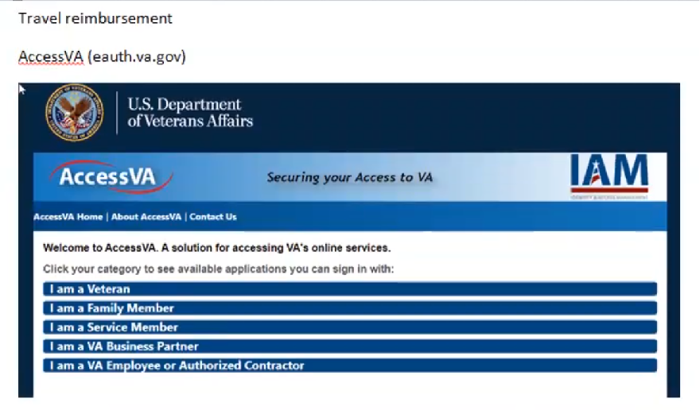

Participant shows Word doc with screenshots and notes of steps he took to try to get travel reimbursement. First step is to select category.

So I follow my instruction sheet I got at the VA. And it’s the same if you go to My Health Vet and do a search for travel reimbursement it will give you link and produces this same screen.

I come here, this sounds pretty simple. I am vet so I click I am a vet then I get this.

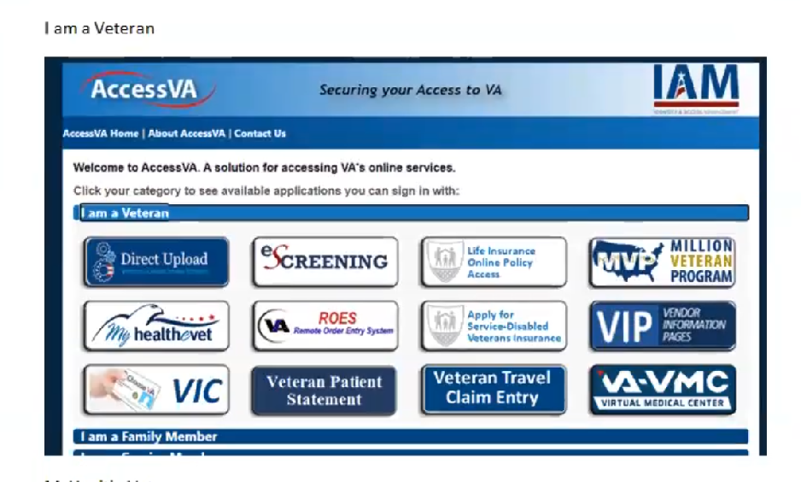

Participant shows next step in his journey to try to get travel reimbursement.

So I am a vet. Here are some online services. I don’t know any of these other than My Health Vet, which what I signed into to get here.

My assumption is, because I don’t know anything about these other ones that I think I should be clicking on My Health Vet. That’s logical to me because I don’t know what the other ones are. And I am assuming because I got her from My Health Vet, why is it even asking me. Why do should I even make a choice.

That may not be the intent of the programmers choices but that is what I perceive. So I perceive I should click My Health Vet. If I click another one I am going to go off to lala land and I won’t know where the heck I am.

Keeping in mind I am just trying to find that travel form.

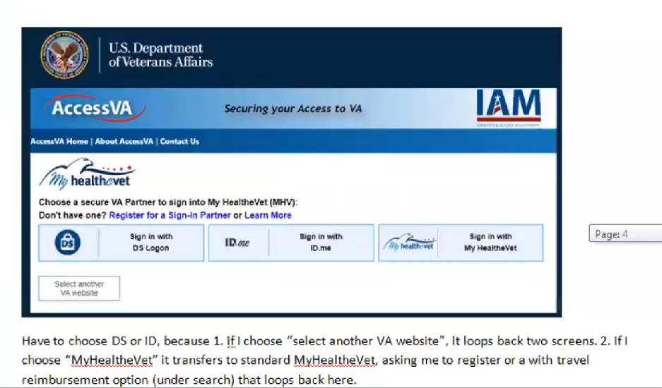

Participant shows screen shot of next step he took to try to get travel reimbursement. He has clicked on My HealtheVet button and is being asked to sign in.

So I come down here. It asks which one of these I want to sign in with. Well, I just told you. *Participant laughs*. It gives you three more choices. Number one, I signed in under My Health Vet then chose, My Health Vet the screen before this, and now I have to choose My Health Vet again. *Participant laughs*. Now I am confused.

Okay so I have to choose DS or [ID.me](http://ID.me) because if I choose My Health Vet, which I am familiar with, it loops back to the first screen.

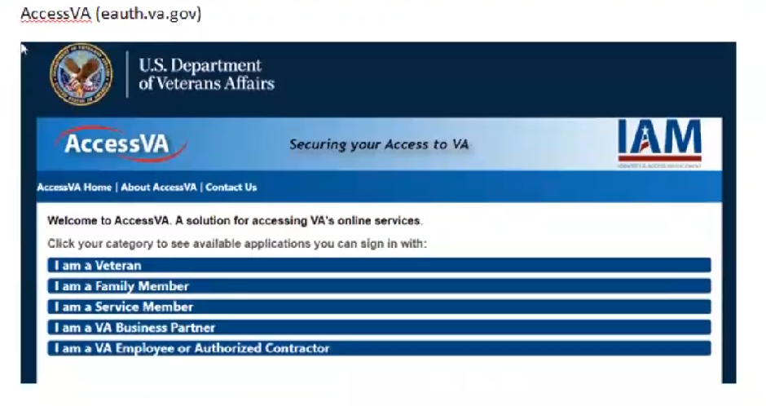

Participant shows screenshot of first step again indicating there he has experienced an endless loop when trying to get travel reimbursement.

1. **What did you click on to loop back to the first screen**:

My Health Vet. It loops be to where I started to begin with. Actually if I pick “Select another VA website” that takes me back.

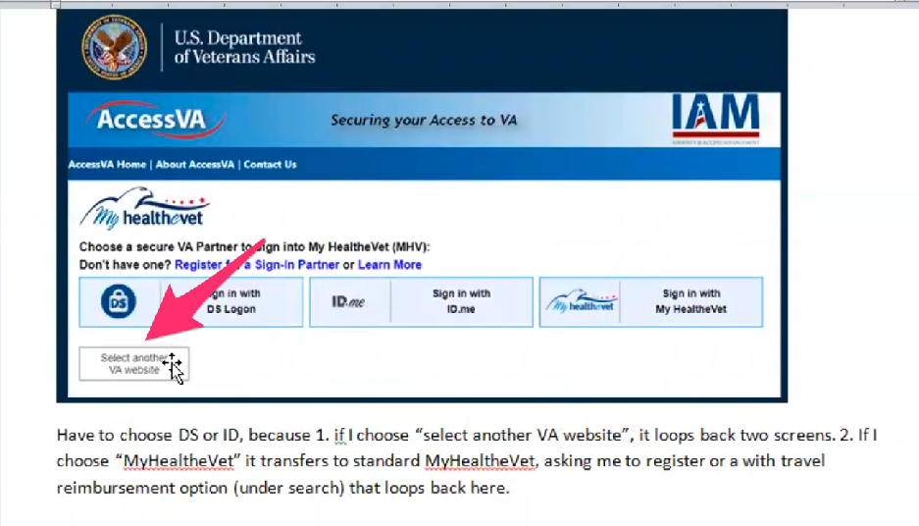

Participant shows screenshot and “Select another VA website” button he selected to loop back to the beginning of trying to get travel reimbursement.

Now if I click select another that takes me back which doesn’t make sense in my head either.

If I click My Health Vet it takes me all way back to where I started to my health vets.

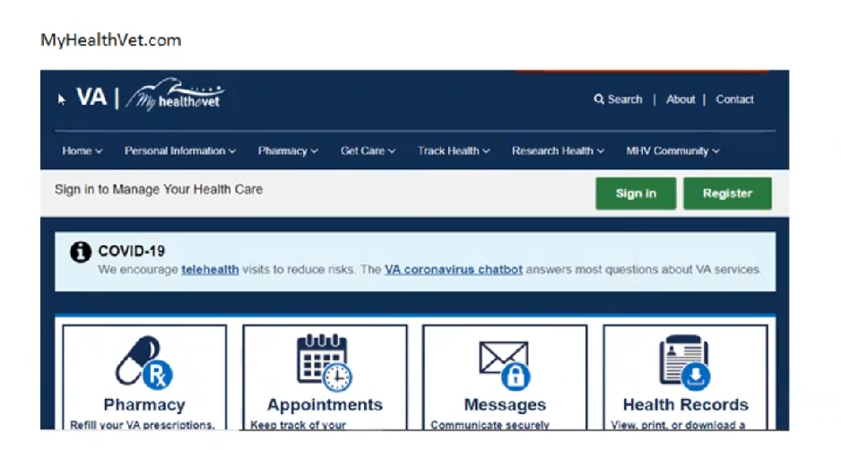

Participant shows screenshot of My HealtheVet home page. Explains this is what he gets if he clicks “Sign in with My HealtheVet” login option.

I still can’t get my claim forms.

If I go to try to figure out where it might be [on My HealtheVet home page].

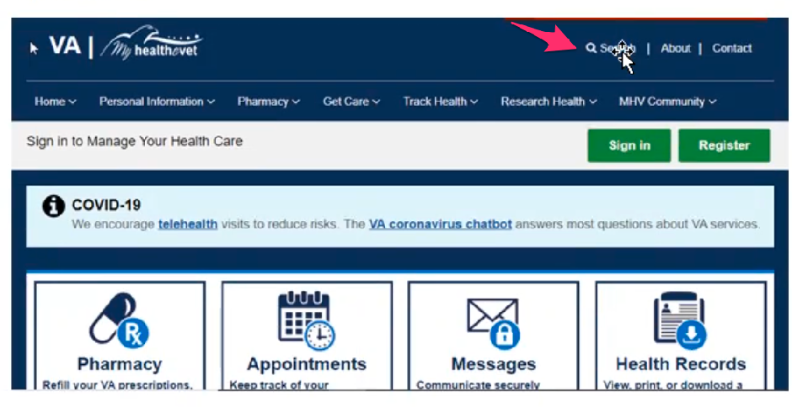

Participant shows where he found Search in the upper right corner of My HealtheVet home page.

If I hit search and type in travel reimbursement or claim form or whatever. Then I get sent back.…

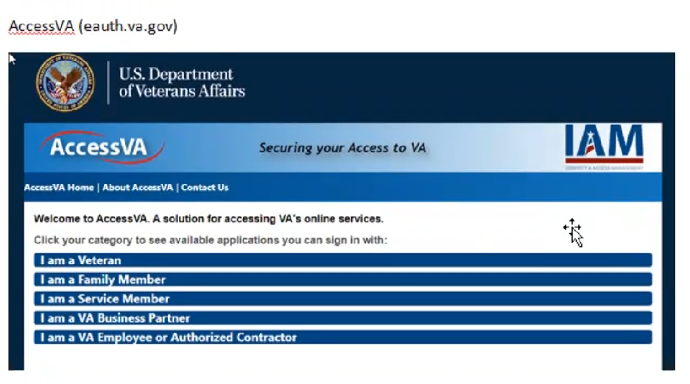

Participant shows screenshot of the AccessVA site that was the start of his journey to get travel reimbursement.

…to here I am sent back to the Access VA page. I am missing something. So that won’t work. *Participant laughs.*

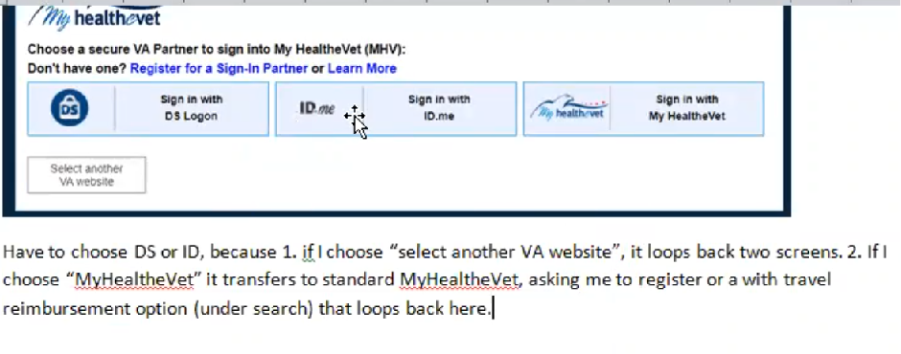

Participant goes back to login options and points out “Sign in with DS logon” and “Sign in with [ID.me](http://ID.me)".

So if I choose one of these two which I am not familiar with. I am guessing these are the only two I can choose from. I have to go through another registration process for ID.me or DS whichever one I prefer. But I don’t know which one I prefer. I’ve never been on one of those.

And when I click on one of those to register, I have to jump through a whole bunch of questions.

I guess my point is, I am already registered under My Health Vet. Why do I care who these partners are. Why do I care which one I connect to. *Participant is referring to the three sign in options DS,* [ID.me](http://ID.me)*, and My HealtheVet.*

Why isn’t it the one I already connect with, which takes me back, which only exacerbates the situation. *Participant is referring to endless loop.*

This is what happens every time. I am just signing on to My Health Vet.

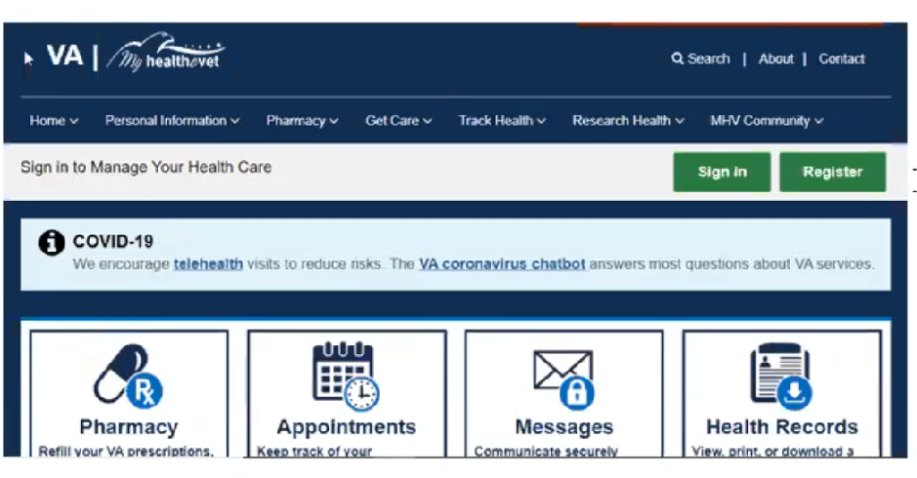

Participant shows My HealtheVet home page screenshot.

It brings this up. This is just any day everyday. Whatever it is I may have a question on. Maybe to refill a prescription. I get online and I sign in.

Unlike numerous other software packages, if I have saved my password and e-credentials I shouldn’t even have to sign in. It it knows me. My Windows operating system has that feature turned on. So I shouldn’t need this screen but I do. *Participant is referring to being asked to sign in multiple times to My HealtheVet instead of his computer remembering he is already signed in.*

So I hit sign in button. P*artcipant is referring to green “Sign in” button at top right of My HealtheVet home page.*

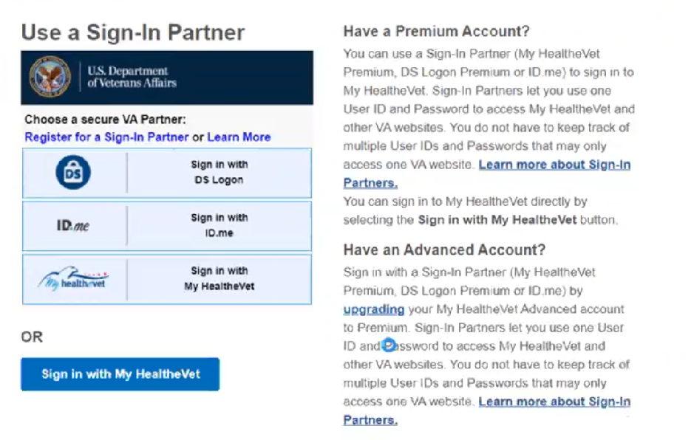

Participant shows screenshot of sign in page and options on My HealtheVet.

Then I get this second screen. This has been frustrating for like the past year or more. And again. Lookey here. See the DS and ID is still there. And My Heath Vet or sign in with My Health Vet. These are identical are they not? Are they two different things? *Participant is referring to the secure partner sign in option My HealtheVet and blue button sign in option for My HealtheVet.*

1. **Tell me your best guess as to why there are two My Health Vet options:**

I haven’t gotten a clue. *Participant laughs.*

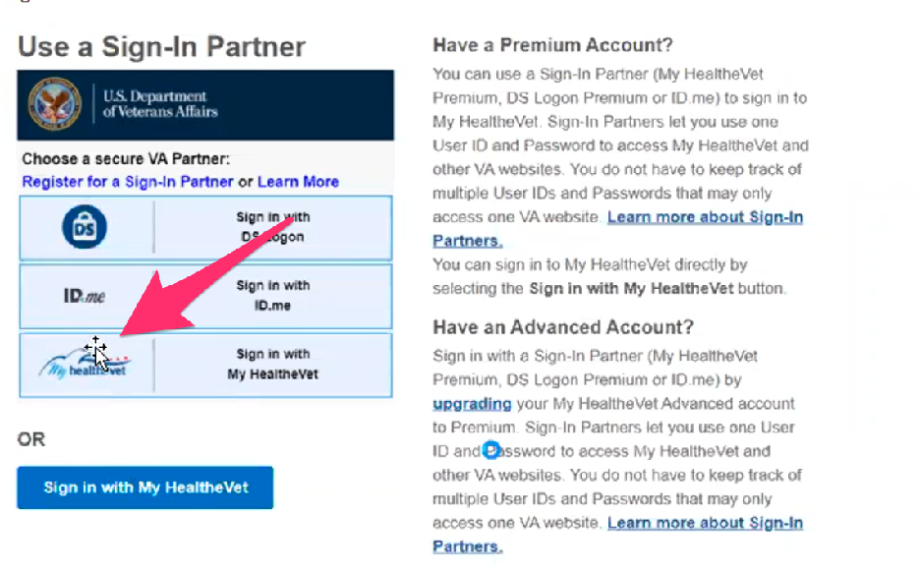

Participant hovers over secure VA Partner My HealtheVet login. Indicates this may be an option if you need to register for My HealtheVet and not if you already have an account.

Unless this is just to register for.

But again if we are working with the most popular operating system out there, sign in as soon as I launch this website. If it is holding my password and id it should know that I am a Health Vet.

This I will guess after reading it a little bit more, after seeing it so many times, is registering for one of those three. *Participant is referring again to “secure VA Partner” sign in section.*

If that’s the case, a majority of people coming in here will be users, not wanna be new users. So it oughta be reversed. If this has to be. If this screen has to exist it ought to be flipped up so you can sign in right away. *Participant is suggesting that the blue “Sign in with My HealtheVet” button should be at the top of the page if the other options are to register only.*

That should come secondary. Because vast majority of the users are going to be your users. Anyway that would be my guess.

So I get frustrated with that. I haven’t even signed in yet. So I come down here and I click here sign in My Health Vet.

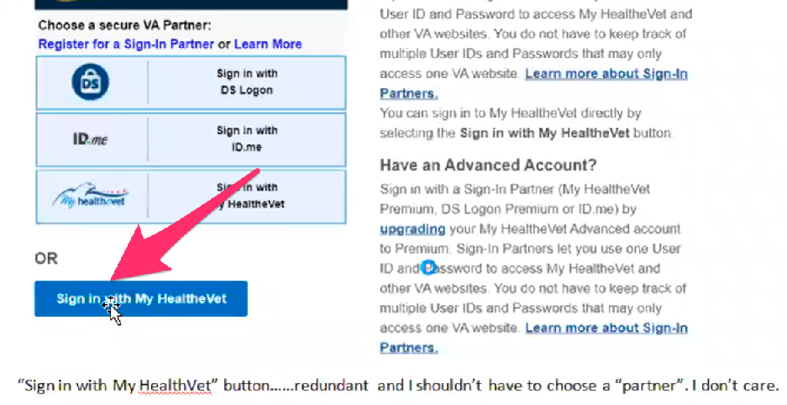

Participant shows they use the blue “Sign in with My HealtheVet” button to login.

It’s redundant. I shouldn’t have to choose a Partner. I don’t care. *Participant is reading notes he took on his Word doc.*

I’ve already chosen a partner when I registered.

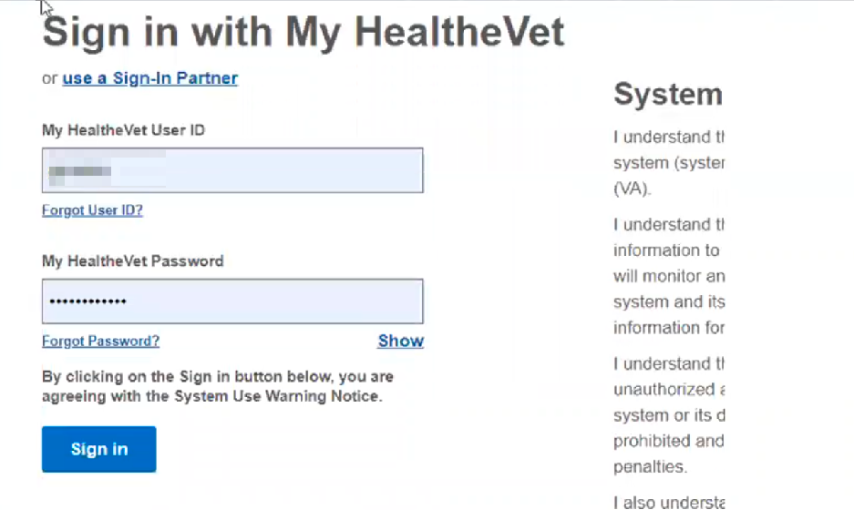

Participant shows sign in form on Sign in with My HealtheVet page.

Oh but now I can sign in. *Participants laughs.*

I am on my third screen just to sign in. It just seems so redundant and silly. It kinda supports all of the not so nice comments about the government being too big.

It seems silly, why didn’t it know that at the beginning. If it knows it now, what did I do differently that this couldn’t be the first screen. *Participant is referring to the fact that his login credentials were auto-filled into the sign in form. Participant is frustrated that if the computer has his credentials, and can auto fill the form, why does he have to keep submitting the form to be signed into he website. Participant is also suggesting there could be a sign in form on the My HealtheVet home page and not have so many steps to get to the form.*

When I designed computer screens and so on we’d always joke about what they call your white space. I understand you are designing it for old farts like me who can’t see. This has so much white space I will wear out my little scrolling button. *Participant is still looking at sign in form screenshot.*

But anyway, here I am on my third screen, with no apparent need to have the previous two screens. In my less than humble opinion.

The I hit the sign in button.

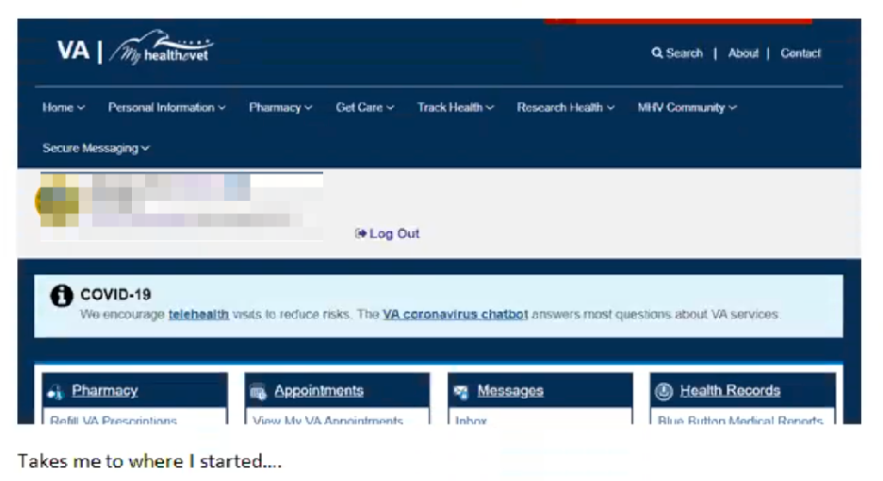

Participant shows screenshot of My HealtheVet home page after logged in.

And my 4th screen looks identical to my first screen. *Participant laughs.* Well, that was fun.

Ok, so those are the only two I documented for you.

I get that there are numerous partners and online services and some of these things are very important to other people.

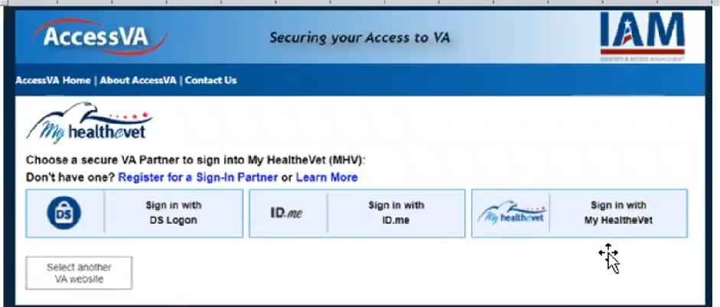

Participant shows screenshot of AccessVA My HealtheVet login page.

But if you signed up with any particular partner, I don’t understand why they can’t behind the scenes shake hands. If I am signed up here [My HealtheVet] why can’t I be on the others with the caveat that if these [DS and [ID.me](http://ID.me)] have access to information this [My HealtheVet] then I just don’t have access to them.

But inside the computer system, and I understand there are multiple systems. But it seems to me we’re looking to be user friendly, and I realize it needs to be functional, and there are security reasons for each platform, and each host, and each partner. There is no reason the matrix can’t be there unless they just don’t want to do it.

Sometimes there are proprietary software and no matter how much money you throw at it they aren’t going to shake hands. They are just not going to do it.

But I would think from a customer service standpoint, people a user might call, say I can’t do this or I can’t do that. I would think from a customer support stand point that they would be able to access the same thing that the user is looking at. Oh I’m ID guy I can’t help Health Vets you’re going to have to call this guy. *Participant is thinking through how siloed login systems might effect customer support as well.*

Thats the constant battle.Instead of the old days when it between two things - it’s not a hardware problem it’s a software problem. Oh its not a software problem it’s a hardware problem. Now more and more it’s - it’s not my application problem it’s your application problem. We think we’d want to minimize that. *Participant is reflecting on experience working with computer systems and how that has changed over the years.*

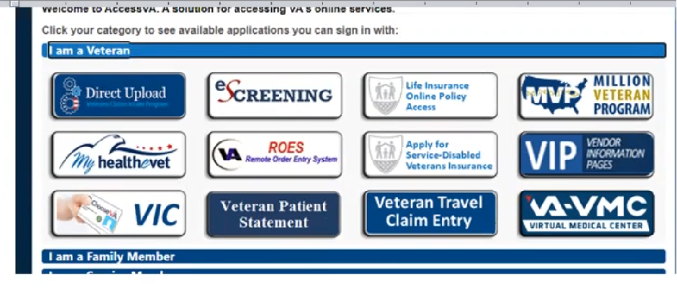

Participant shows screenshot of AccessVA “I am a Veteran” options.

This is another term we use to use, is the fog index. This has so much fog that you can’t see what you needed to do. *Participant is moving cursor over all the options on the AccessVA screenshot.* So fog index is high on this screen, as helpful as it is trying to be it is just creating fog.

**Curious on those sign in partners. What is your thinking about what’s different between these and what these are:**



Participant shows screenshot of sign in page and options on My HealtheVet.

I am going to guess that these three [DS, [ID.me](http://ID.me), and My HealtheVet ] support or drive some of these [AccessVA options for Veterans]



Participant shows screenshot of AccessVA “I am a Veteran” options.

I am just guessing. As an example ID.me maybe they run a few programs, I don’t know but I am guessing. Then maybe DS runs a few programs or the other ones. I guess my Health Vet runs my Health Vet. *Participant is suggesting that the login options may be unique to certain programs listed on AccessVA. So the user should know which login to use.*

That is pure speculation. I will guess I can only qualify for certain things here.

Oh! Look Veteran Travel Claim entry. I didn’t even see that.

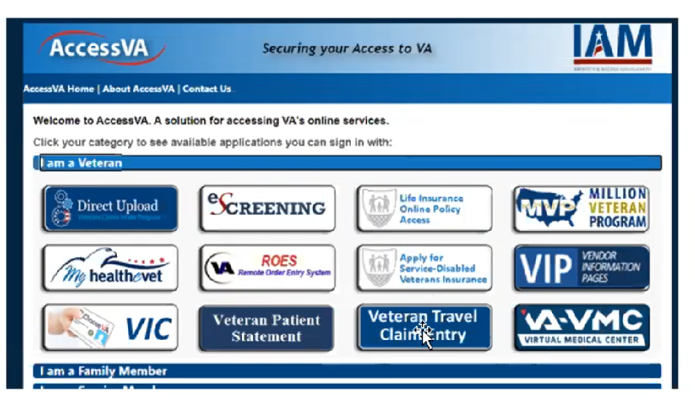

In showing screenshot Participant sees “Veteran Travel Claim Entry” button that might be option to get travel reimbursements.

I will have to click on that when we get done.

There’s just so much fog in there I didn’t even read it.

I only saw my HealtheVet, my head was so wrapped up in these things [all the login options on My HealtheVet] so my brain said oh more crap.

I will have to try that. Good thing we had this little conversation. *Participant laughs.*

This is wild speculation. Maybe for these three here [eScreening button, ROES button, and Veteran Patient Statement button] I have to have three green toes and purple underwear. I don’t qualify for those, I get that I shouldn’t have access to it. So even if I signed in and they acknowledge that I am a valid veteran, I may have access, but I can’t do 12 of the 13 things to those that are eligible.

I understand the concept of keeping it secure and only having access to what you should.

But it seems like there should be a simpler way.

Or for the user to read the damn screen would help. *Participant laughs.*

Now I’d like to ask you how you manage information and tasks related to [Veteran's] health care. For each one, talk me through the steps you’d take. If there is something that you go online to complete, I may ask you to share your screen so I can see what you would do. **(10 minutes)**

**Tasks** Moderator should prompt about device usage if participant mentions digital tools or resources.

* **How would you reach out to you VA care team if you had a question?**

I definitely would go online for that. I use to try to call but that’s a lost cause.

I go to my favorites list because I am used to it.

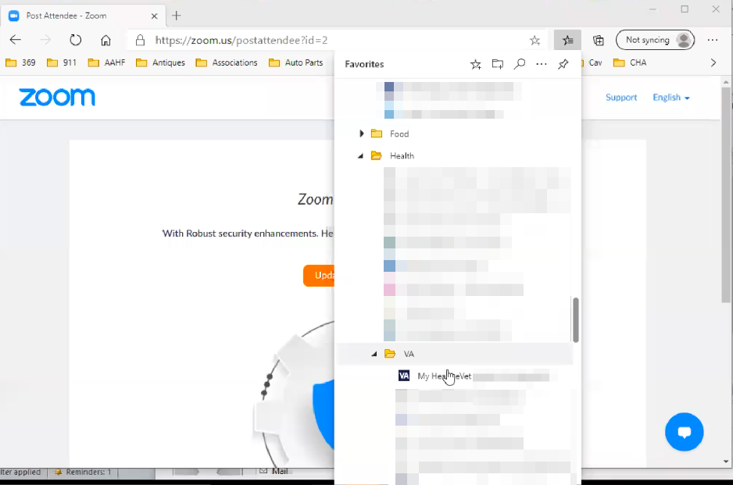

Participant has site bookmarked in Edge favorites.

VA folders click My Health Vet. This is my fun part of signing in.

Now I can sign in. I am back to the part we just went through.

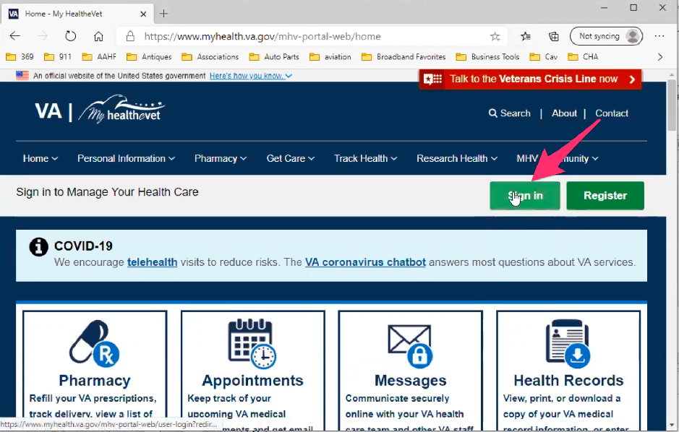

Participant clicks on green “Sign in” button on top right of My HealtheVet home page.

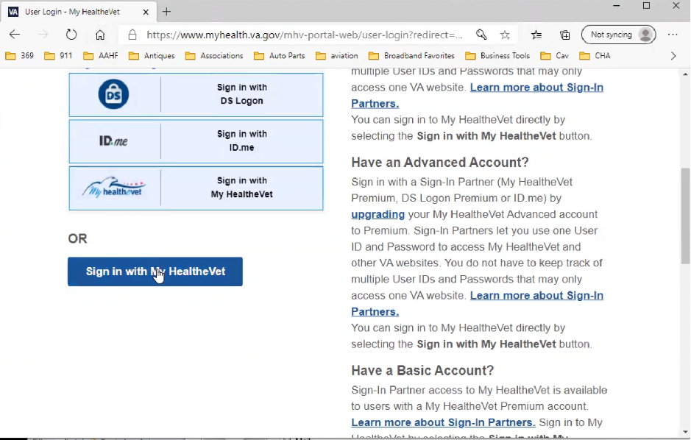

Participant points out top three sign in options, reiterates how they are frustrating, but he has learned to ignore them. Participant clicks on blue “Sign in with My HealtheVet” button.

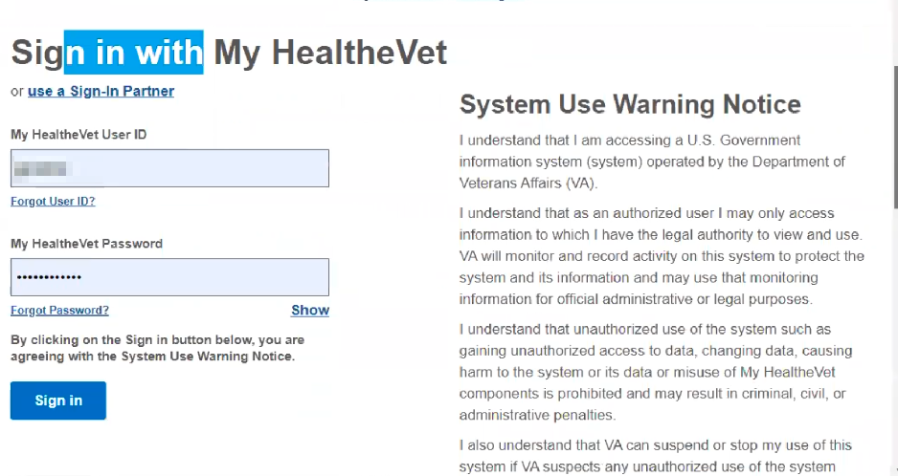

Participant signs in. User id and password were auto-filled in form field.

So I sign in.

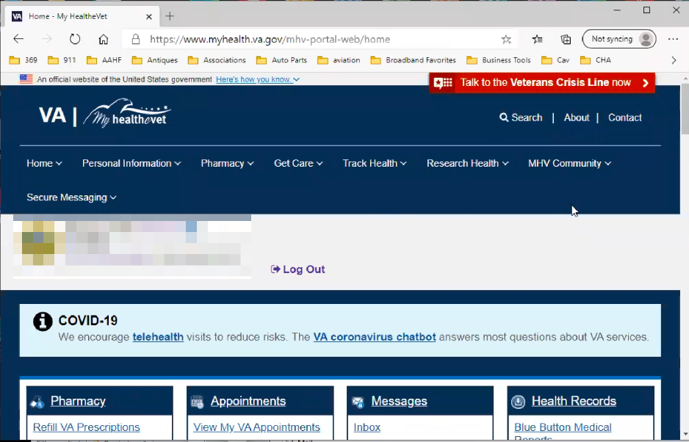

After sign in Participant is redirect back to home page on My HealtheVet.

And I’m back to where I started anyway.

I would go down here, secure messaging and then go to secure messaging.

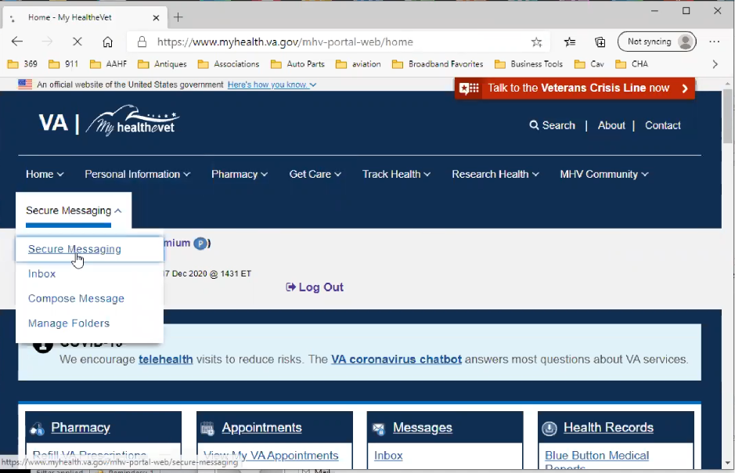

Participant hovers over “Secure Messaging” in main navigation and clicks on “Secure Messaging” link in the sub menu drop down.

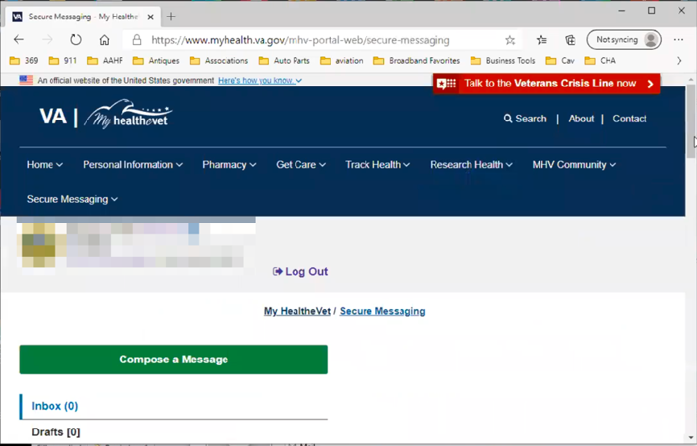

Secure Messaging page loads. Participants small browser window seems to be causing an odd layout. The main inbox content is wrapping below the left side navigation.

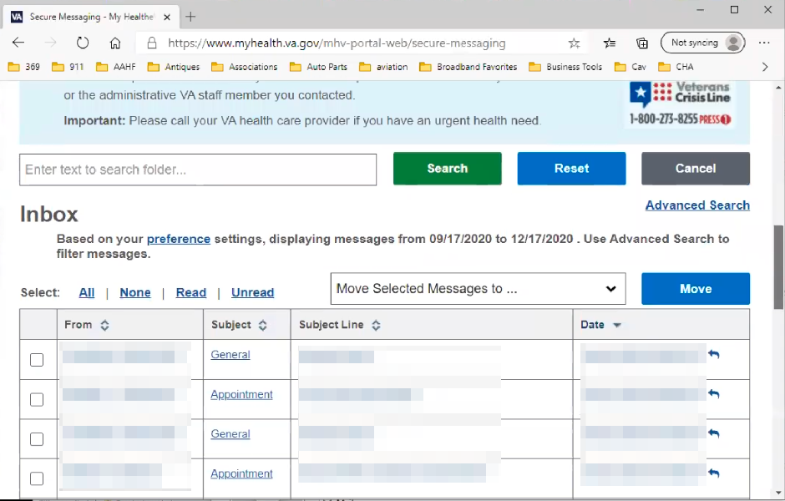

Participant scrolls down to Inbox looking for “Compose a Message” button.

And then I hit hit hit hit hit hit. *Participant is searching for compose message button but can’t find it.*

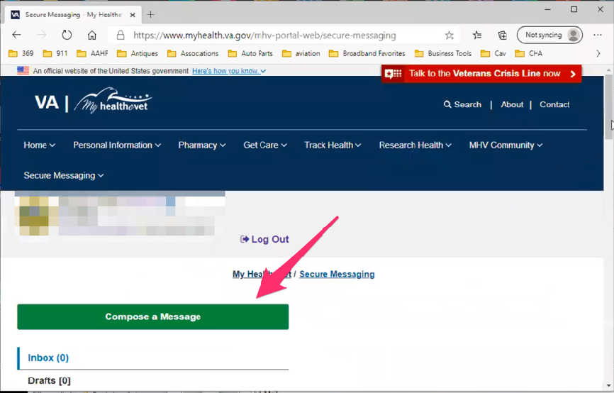

Participant scrolls back up to the top of the page. Sees green “Compose a Message” button and says oh!

Participant clicks on the green “Compose a Message” button.

Oh, compose a message. Again all this white space drives me nuts. Because I know every time I gotta pull up a screen I have to scroll down no matter what. *Participant is referring to layout issue where main inbox content is below left side navigation.*

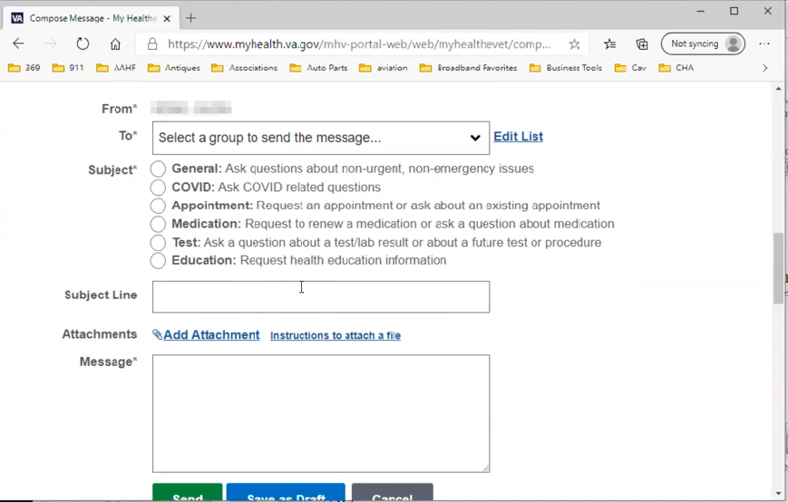

Participant scrolls down Compose a Message page to show message form.

Secure messaging has been very successful for me. A few blips by far and large this has been much more effective then trying to call. I assume you are familiar with this.

* **When you sent a message before, how quick was the response:**

Within 3-6 hours I will get a response. It may not answer my question. On a rare instance I will get an immediate response. If the nurse practitioner was on the screen at the same time I would get an instant response.

But I would say 3-6 hours to get a response and certainly within 2 days I had a resolution.

Some of it is the dependent. Like if it’s something like my prescription should have arrived but it didn’t arrive. They will respond to me. Someones got their eyeball on it. Either someone likes the system, otherwise someone is dedicated to it.

It’s been good. I would give it an A. I won’t give it an A plus because there’s always room for improvement.

Far superior to the call center.

* **When you receive a response, how are you notified:**

It comes across as an alert on my email. It directing me to check, all my emails go to my laptop and my phone. So it’s pretty much instantaneous once the response is logged here [My HealtheVet] I will know of it. I may not look at it but I know at least the response is in the queue. You set all that up, and it seems to work fine.

* **When you set it up what are you referring to:**

The alert. It’s all under the preferences and stuff like that.

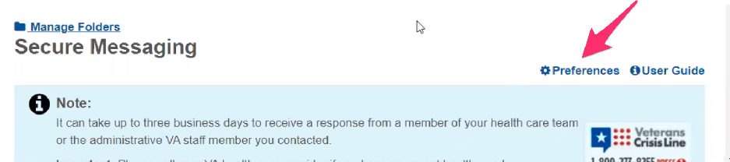

Participant points out “Preferences” link on Secure Message page.

* **How would you refill a prescription you have with the VA?**

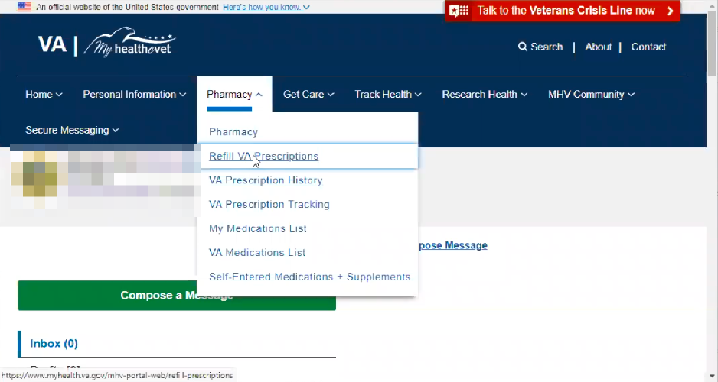

Participant hovers over “Pharmacy” in main navigation and clicks on “Refill VA Prescriptions” link in the sub menu drop down.

Same thing, I would go to pharmacy, refill prescriptions.

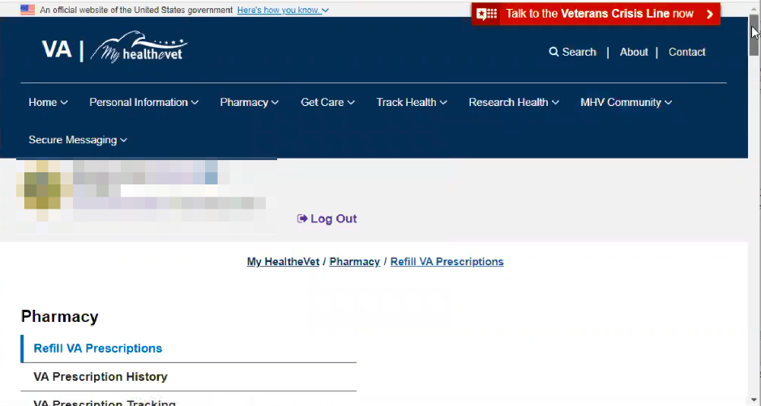

Refill VA Prescriptions page loads. Participants small browser window seems to be causing an odd layout. The main content is wrapping below the left side navigation.

Then again all of this white white white white white white. *Participant is talking about how far they have to scroll to get to prescription list/table. Considers everything above that, including disclaimer/help text, white space.*

I have already asked to refill a prescription, that is what I selects so this is what I want to see.

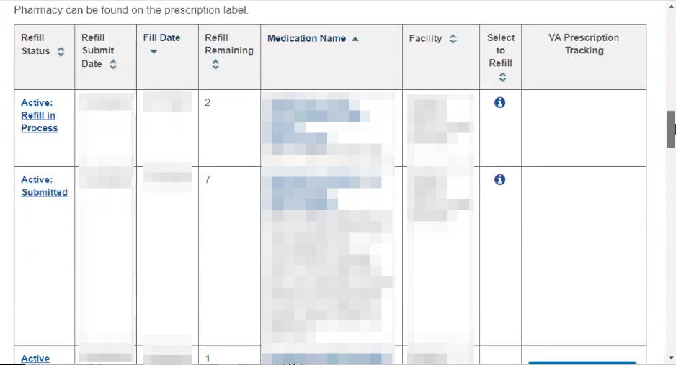

Participant scrolls down to prescription list/table.

This I have a little bit of issues with. It is kind of weird. Ahhh I am not sure how to describe it. *Participant is looking at prescription list.*

Some of these are automatic and some of these are not and I guess that’s what this is supposed to be for. *Participant is referring to “Select to Refill” tooltip.*



Participant hovers over “I” icon on in “Select a Refill” column and reads tool tip.

Some of these are automatic and I can’t even ask for a refill because it will only allows you. But I am sure that whatever this item is, whatever this medication is, has it's parameters of whether I can ask for a refill. Or it can be refilled at a predetermined time because either limited availability, it’s narcotic value, who knows what the criteria are.

They don’t want you getting a whole years worth when the shelf life is for 2 weeks. Or selling it on the corner. I am sure there is some criteria there.

I mean it is workable but it is just a little strange how some things. Like this track delivery seems to be worthless.

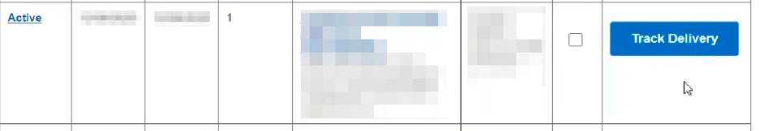

Participant is showing Track Delivery button for a prescription.

I ordered them last week and it just says it is being tracked and it is sends over to UPS or FEDEX or something like that. Ok let me see what it says today.

*Participant clicks blue “Track Delivery” button.*

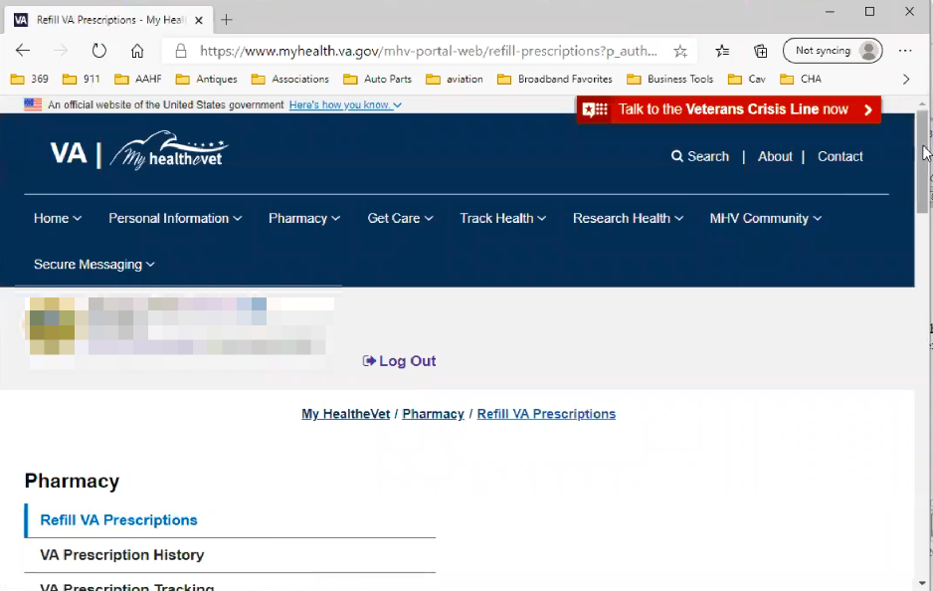

Refill VA Prescriptions page loads. Participants small browser window seems to be causing an odd layout. The main content is wrapping below the left side navigation.

So it goes to another VA thing. White white white white white white. *Participant is talking about how far they have to scroll to get to “Prescription Information”. Considers everything above that, including disclaimer/help text, white space.*

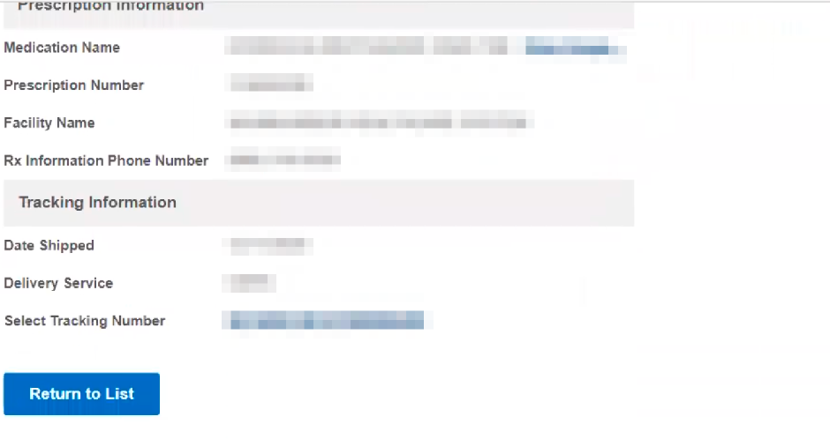

Participant scrolls down page to view “Prescription Information”

So here’s a tracking number. Well, I just hit a button that says I want to track it. *Participant laughs.* Ok.

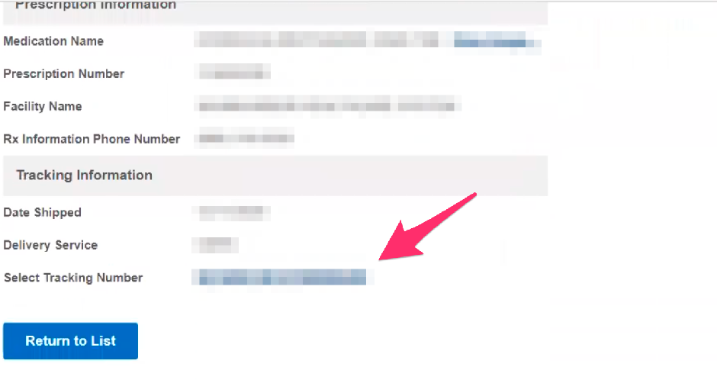

Participant hovers over “Select Tracking Number” link.

Select tracking number. So why is it telling me to select the tracking number. What else would I have done.

*Participant clicks tracking number link.*



Refill VA Prescriptions page loads. Participants small browser window seems to be causing an odd layout. The main content is wrapping below the left side navigation.

So then it goes to another VA. White white white white. *Participant is talking about how far they have to scroll to get to page content.*

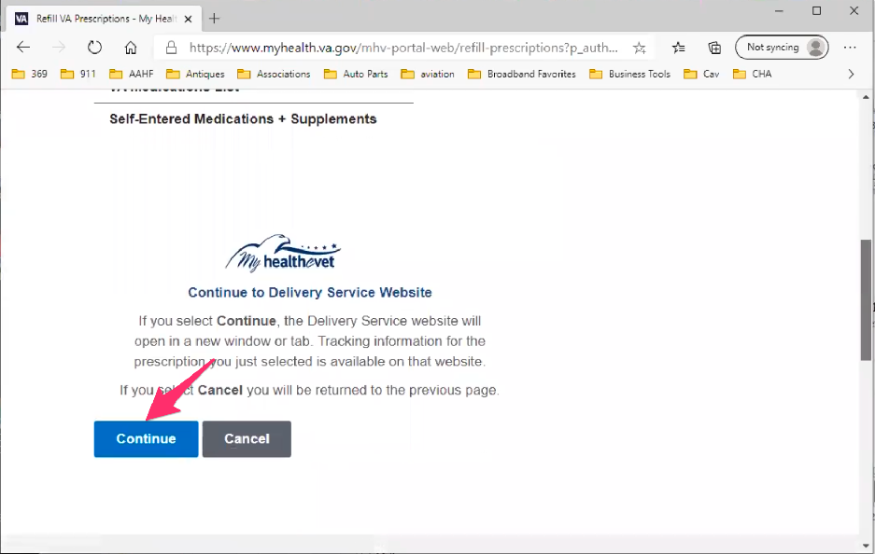

Participant scrolls down page to “Continue to Delivery Service Website” authorization. Participant clicks on blue “Continue” button.

Then there taking you to the delivery service site. Okay, I don’t care. Someone is making mint if they are getting paid per web page.

*Participant clicks blue “Continue” button.*

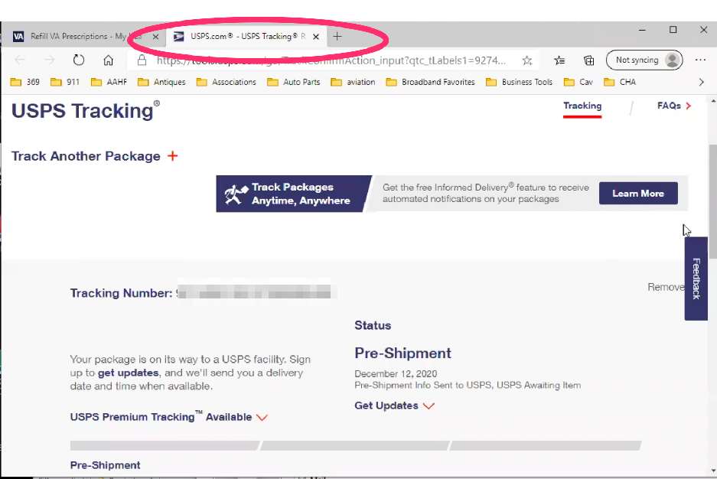

USPS page loads with tracking info in new tab. Participant does not comment on new tab being open.

Play USPS okay so it’s in pre-shipment, I don’t know what that is. Not processed or not shipped would have worked.

* **Noticed only one prescription in your list had track deliver. Is that normally the case or thoughts to why that is:**

I don’t have any thoughts other than now that you asked me.

*Participant closes [USPS.com](http://USPS.com) tab.*

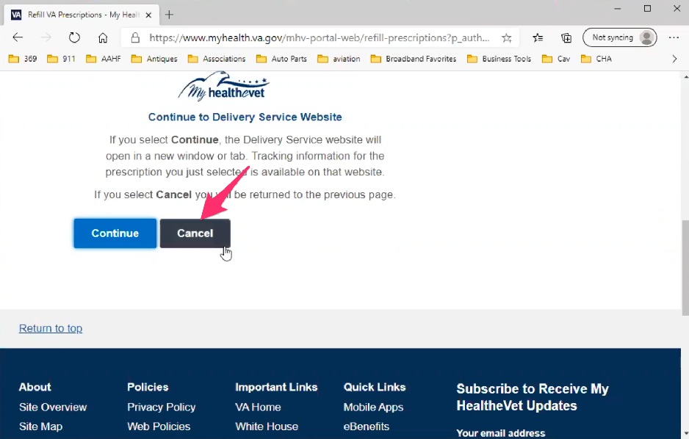

Participant clicks gray “Cancel” button on “Continue to Delivery Service Website” authorization.

If we go back one.

Oh no we have to go back three. *Participant laughs.* Gotta keep everyone employed.

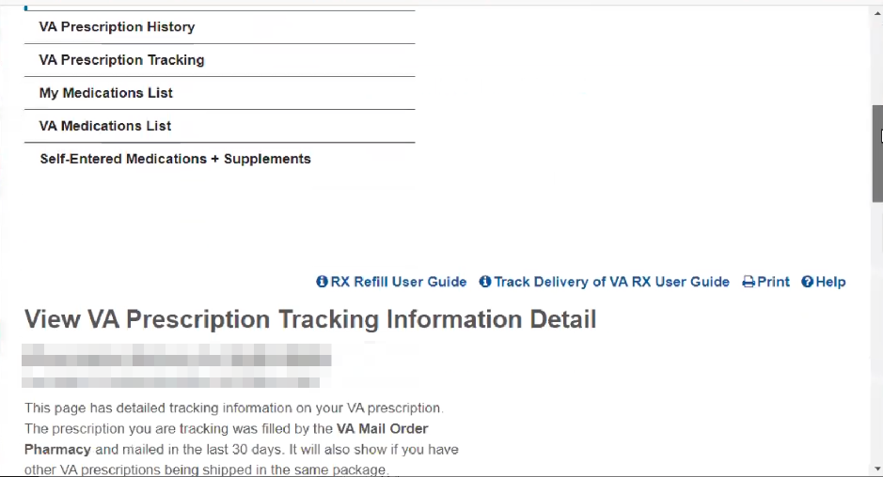

View VA Prescription Tracking Information Detail page loads.

*Participant uses back button in Edge browser to go back.*

Jeeze it was 4.

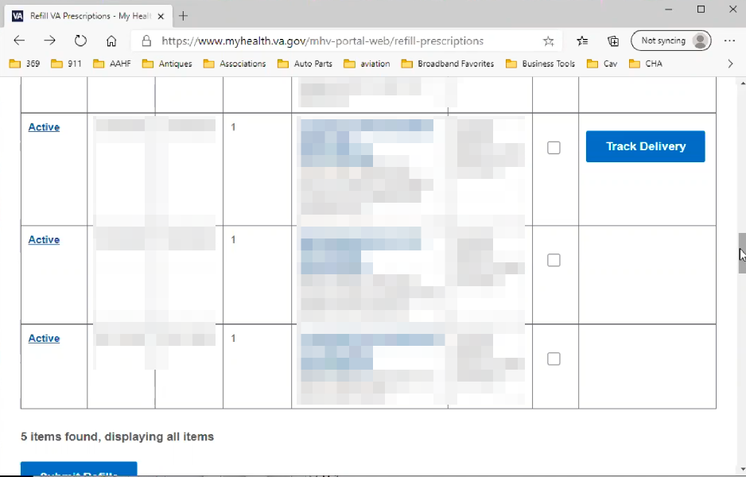

Participant goes back to prescription list/table.

I don’t know why there is track delivery on this one.



Participant tries to get information by hovering over “I” icon on in “Select a Refill” column and reads tool tip.

When, this is when it is confusing. I have 7 refills and I ordered one yesterday to see what would happen and now it says I can’t order it. Does that mean, I am just speculating, I am trying to order 7 of 12 and this is only the 6th month of a 12th month prescription. I don't know.

Back to the tracking. I seldom have this happen. I am going to guess, normally I order it and it will get here in maybe a week or two. On the rare occasion it would be a month. But a week or two is usually just fine.

This is kind of new. *Not clear if participant means tracking feature, or the prescription*. So I don’t know if it is a supply issue. They are trying to imply it has been shipped but it is pre-shipped.

* **When you said this seldom happens, did you mean it’s slower than normal:**

Yeah. Because this item. See this one I am going to have to call on because if this is stuck in traffic I may have to run down to the VA hospital and get some more. Physically because I know although this was done last week. Of course with the holiday delivery garbage yeah.

After this I will need to get on secure messaging to see what the issue is.

I very don’t often see that.

* **How would you view an appointment for your VA healthcare:**

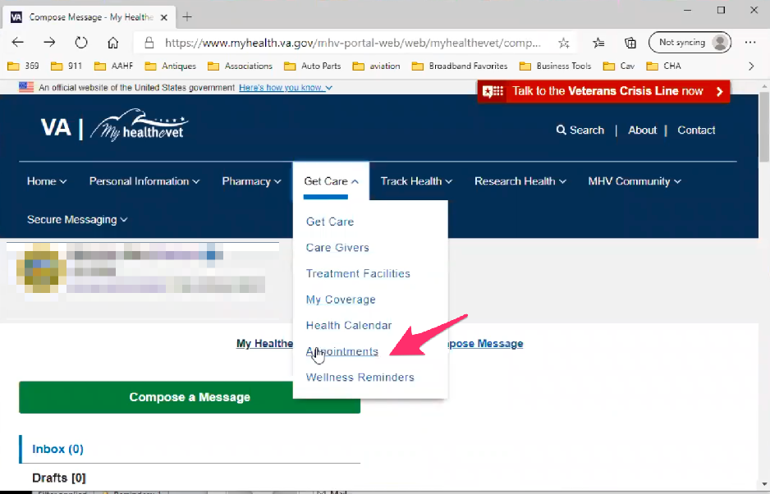

Participant waffles a bit about which main navigation item, hovers over “Get Care” in and clicks “Appointments” link in submenu drop down.

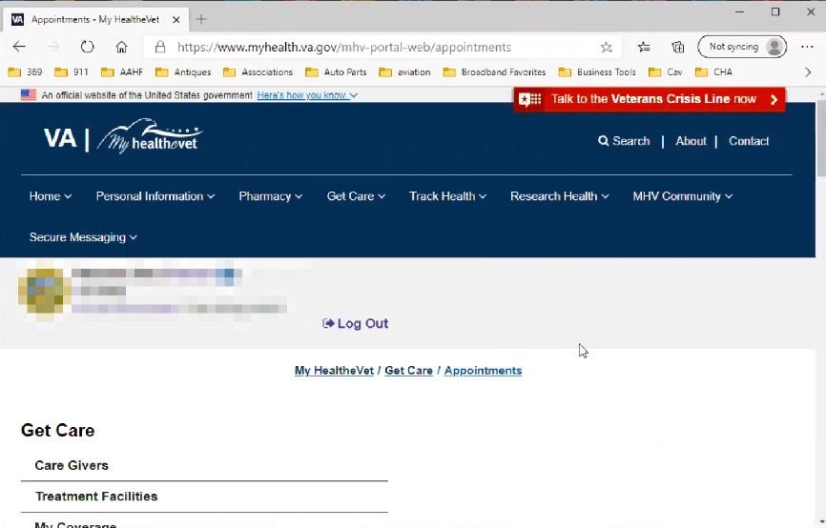

Appointments page loads. Participants small browser window seems to be causing an odd layout. The main content is wrapping below the left side navigation.

White white white white white white. *Participant is talking about how far they have to scroll to get to “VA Appointments Summary”. Considers everything above that, including disclaimer/help text, white space.*

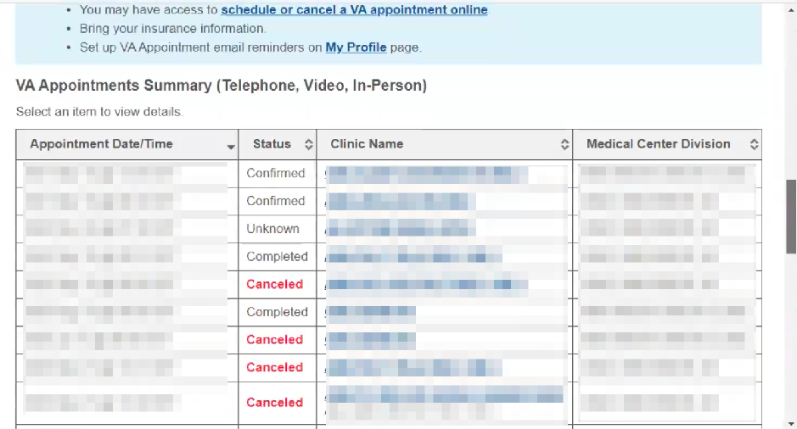

Participant scrolls down Appointments page to show appointments list/table.

You are I come here to check and make sure they are here, to change them, adjust them or send a secure message if needed.

* **Used an online tool to schedule as well:**

Yeah.

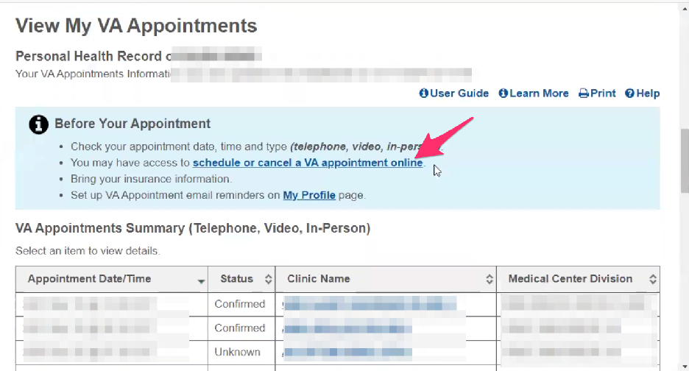

Participant scrolls up and clicks on “schedule or cancel a VA appointment online”. Has no trouble finding it so is probably the link they normally use.

Almost white white white white white. *Participant is talking about how far they have to scroll to get to blue “Schedule or Cancel a VA Appointment” button. Considers everything above that, including disclaimer/help text, white space.*

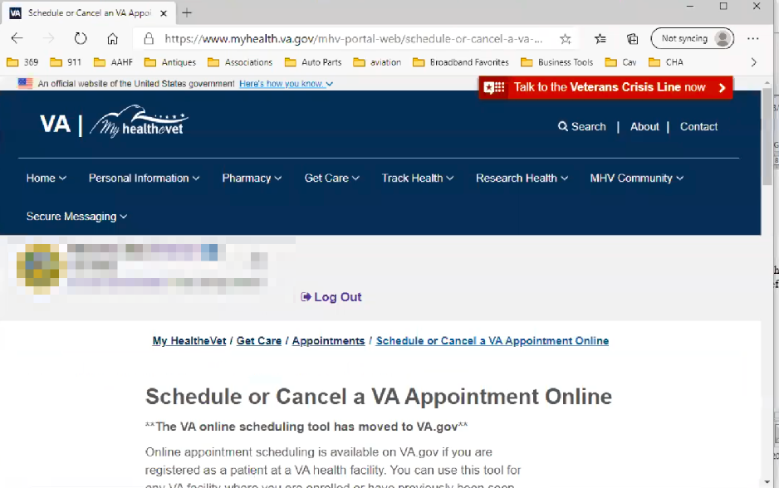

Schedule or Cancel a VA Appointment Online page loads.

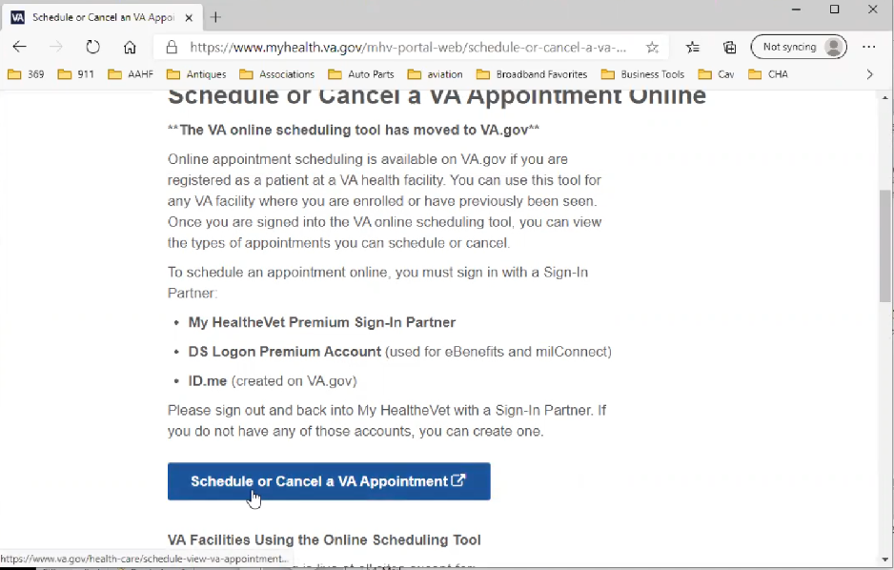

Participant scrolls down page and clicks on blue “Schedule or Cancel a VA Appointment” button.

Again, schedule. Well, yes that’s the button I hit. *Participant is again wondering why the extra step needed. They already clicked a link to schedule an appointment, then have to go to another page and click a button to schedule an appointment.*

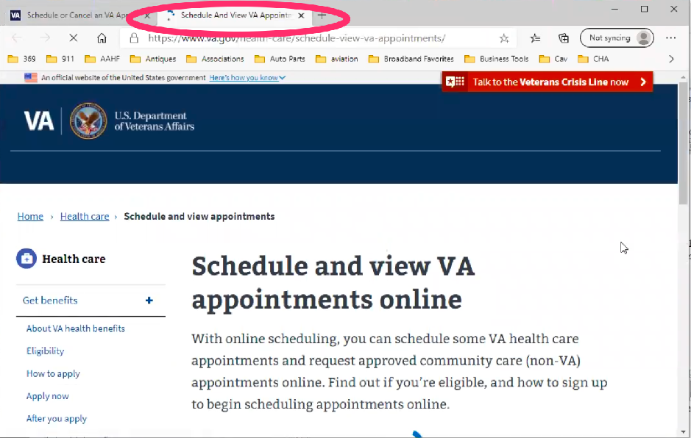

Schedule and View VA Appointments Online page loads in a new tab. Participant does not comment on being in new tab or on a different site.

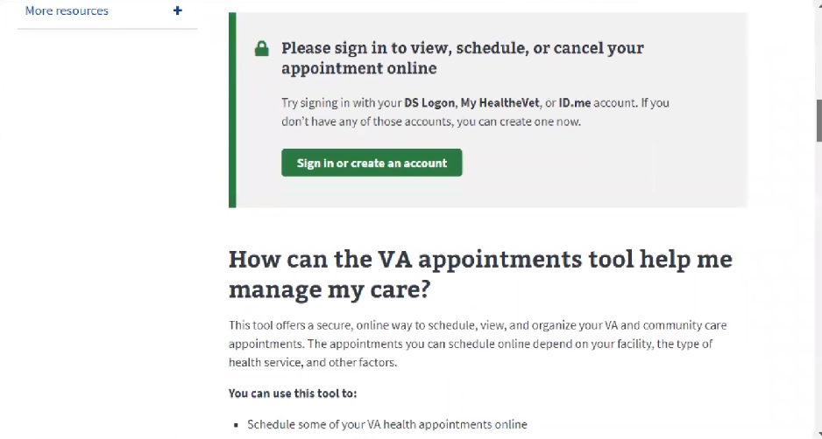

Participant scrolls down page. Reads green “Sign in or create an account” button as “Sign **up** **to** create an account”. Dismisses it and continues scrolling down the page.

*Participant gets to bottom of the page. Scrolls back up to the top of the page. Scrolls past green sign in section.*

*Participant slowly scrolls from top of page down, taking more time to read.*

What I really wanted was, that is different.

Let me see if I started where I thought I started.

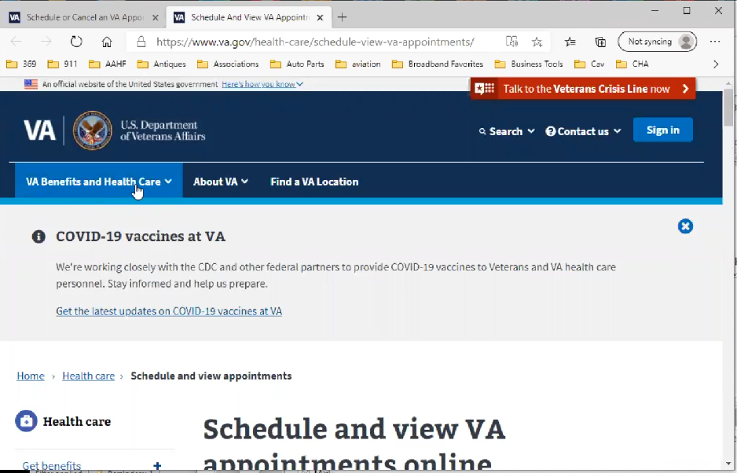

Participant scrolls to top of page to review main navigation. Seem to realize now they are on a different site in a new tab.

Huh. *Participant closes* [VA.gov](http://VA.gov) *tab and goes back to My HealtheVet tab.*

I wonder if this has changed.

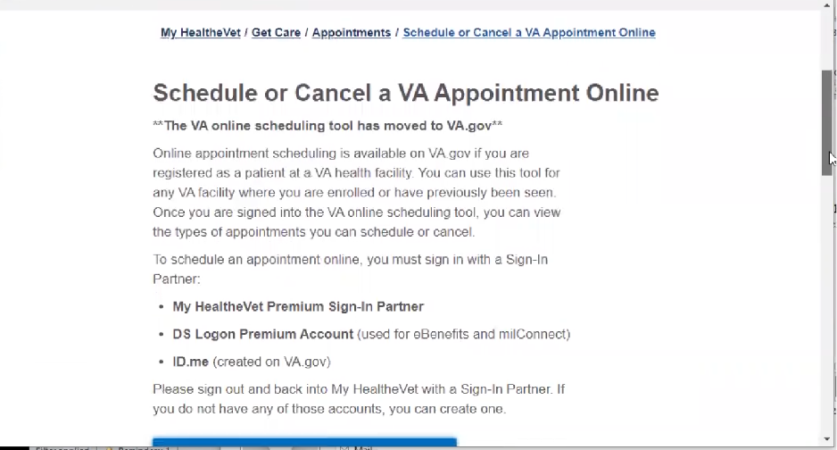

Participant scrolls through Schedule or Cancel a VA Appointment Online page on My HealtheVet site.

Okay schedule or cancel an appointment.

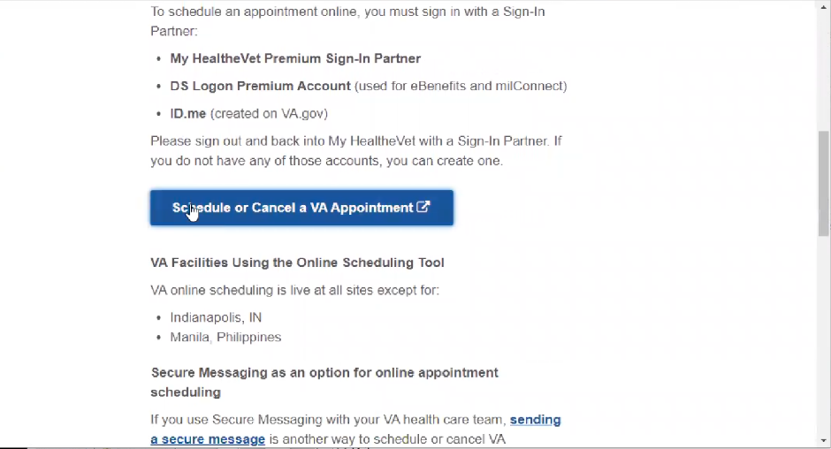

Participant clicks again on blue “Schedule or Cancel a VA Appointment” button.

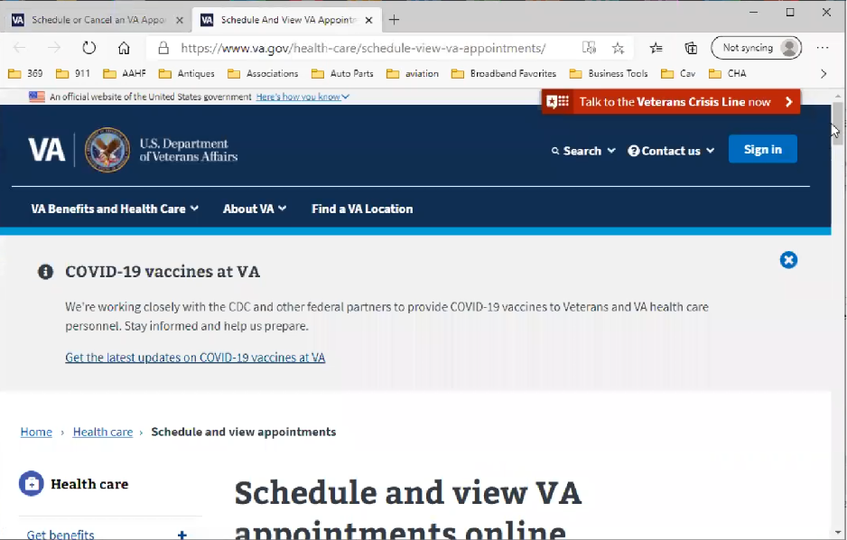

Schedule and View VA Appointments Online page loads. Participant slowly scrolls down page.

After several seconds Participant notices they are on [VA.gov](http://VA.gov) and in a new tab.

Oh yeah. Now it bounced to VA.gov.

* **Have you been here before:**

Yeah. I recall now I was frustrated there because I signed in already to My Health Vet.

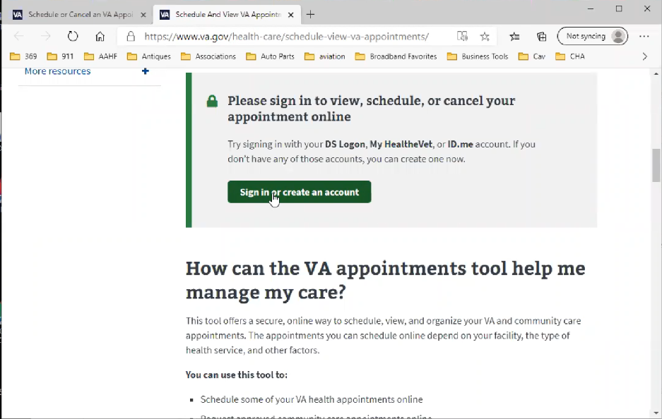

Once Participant realizes they are on [VA.gov](http://VA.gov) they immediately know to use the green “Sign in or create an account” button. They seem to have misread and dismissed it before because they assumed they were still on My HealtheVet and so were already signed in.

Now I am then bumped out to [VA.gov](http://VA.gov).

*Participant clicks green “Sign in or create an account” button.*

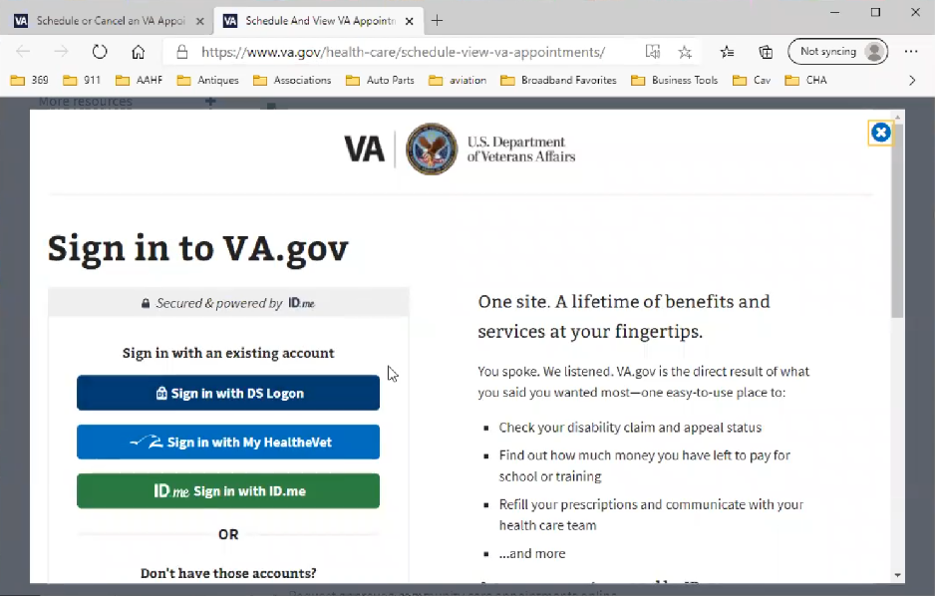

Sign into [VA.gov](http://VA.gov) page loads.

And then here we go again. *Participant laughs.*



Participant clicks on “Sign in with My HealtheVet” button.

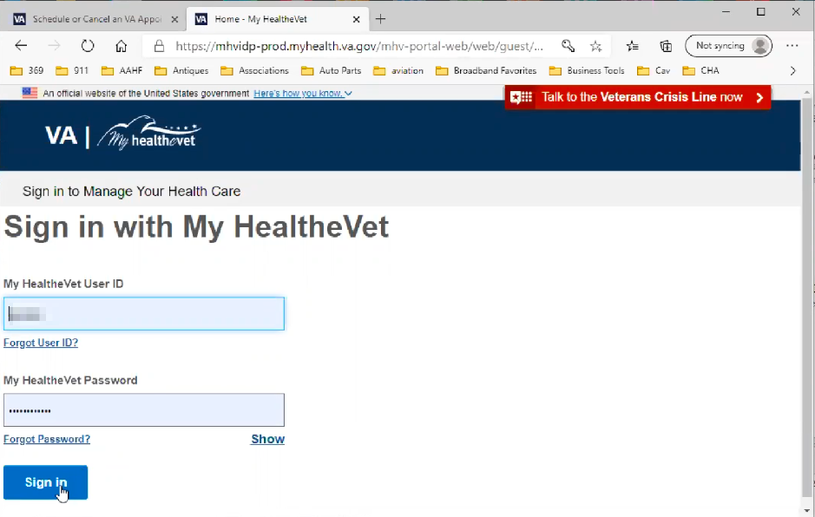

VA Sign in with My HealtheVet login page loads.

And I gotta sign in again.

Tome I haven’t signed out. I understand jumping to VA.gov but to me unnecessary. Because I came from My Health Vet. The credentials should jump over I would think. Because here I am again at Health Vet. I go wait a minute. *In this case the fact that the UI looks the same as the My HealtheVet site sign in confusing for the Participant.*

*Participant signs in.*

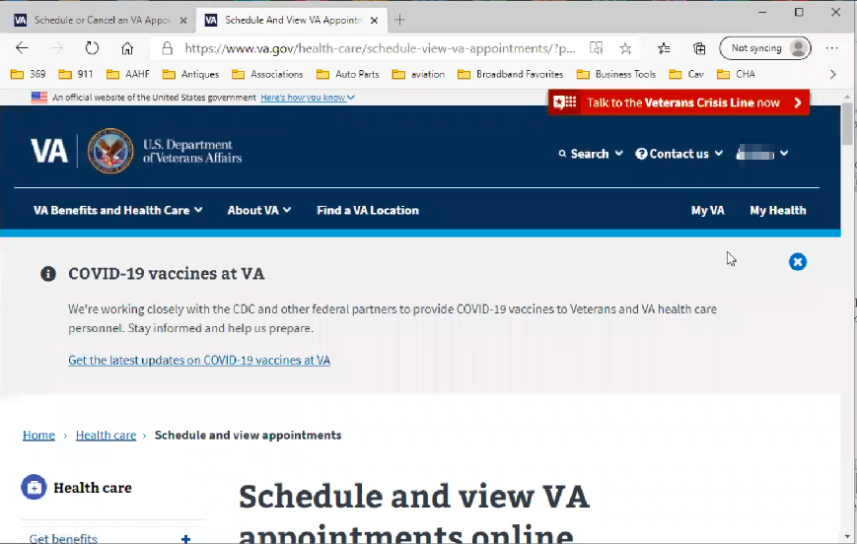

Schedule and View VA Appointments Online page loads.

So back over to VA.gov.

And here I am again.

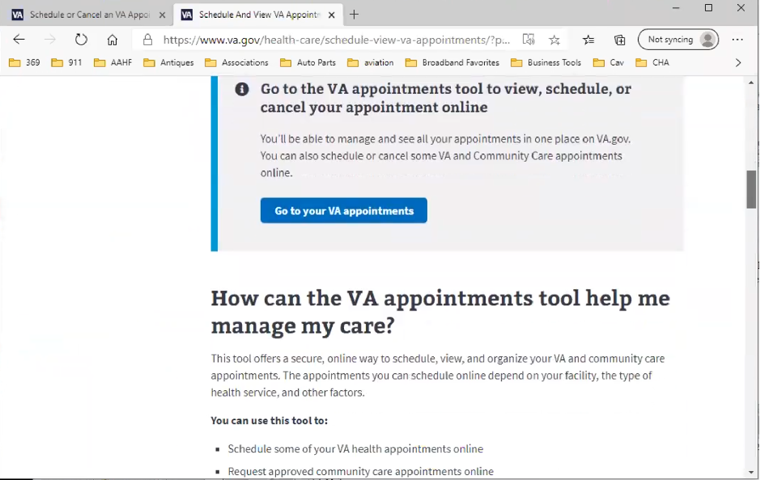

Participant scrolls down the page. Stops at this section for several seconds but then continues scrolling down the page.

And I don’t find any other option.

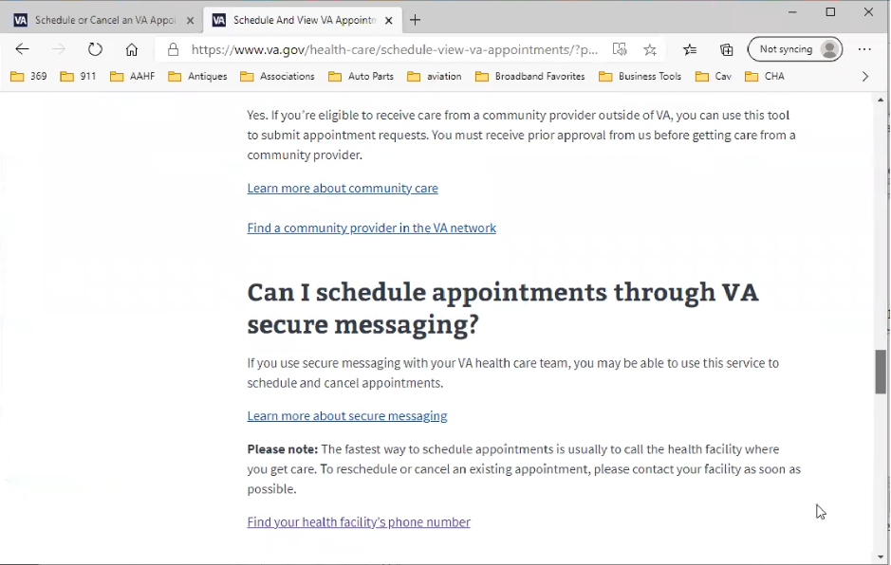

Participant continues to scroll down the page.

Other than if I did it though secure message. *Participant appears to be reading section on scheduling via secure messages.*

*Participant scrolls to end of page and starts scrolling back up.*

Looks like I am in a loop. Am I missing something*.*

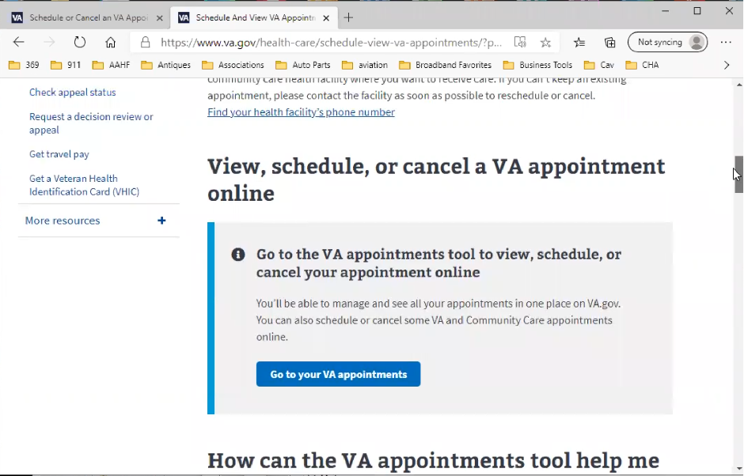

Participant stops scrolling at the “View, schedule, or cancel a VA appointment online” section, but doesn’t seem to register it.

Something has changed from when I actually did it. Because I just made one three weeks ago.

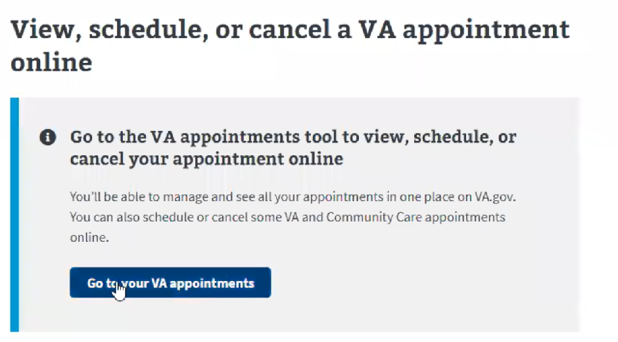

Participant mouses over words as they read “View, schedule, or cancel a VA appointment online” out loud. Participant reads out loud “Go to your VA Appointments” and clicks blue “Go to your VA appointments” button but it doesn’t seem confident in doing so.

Request an appointment. Ok.

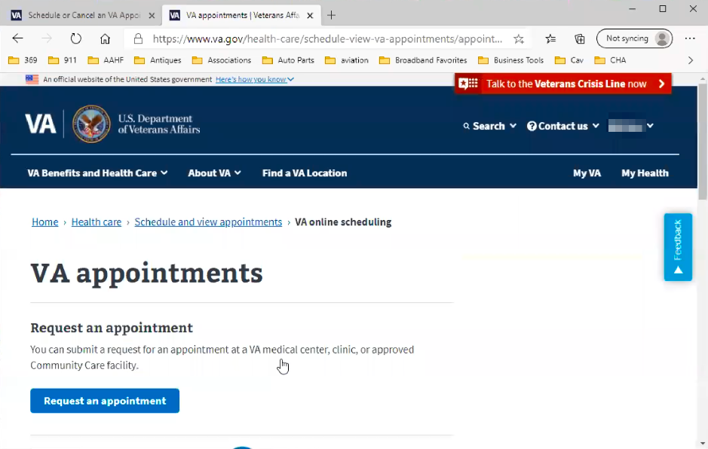

VA appointements page loads.

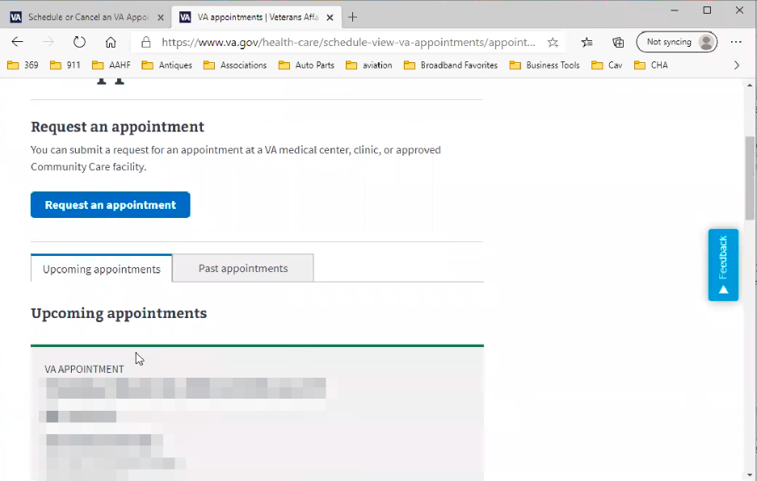

Participant scrolls down page.

I don’t know what I did differently this time.

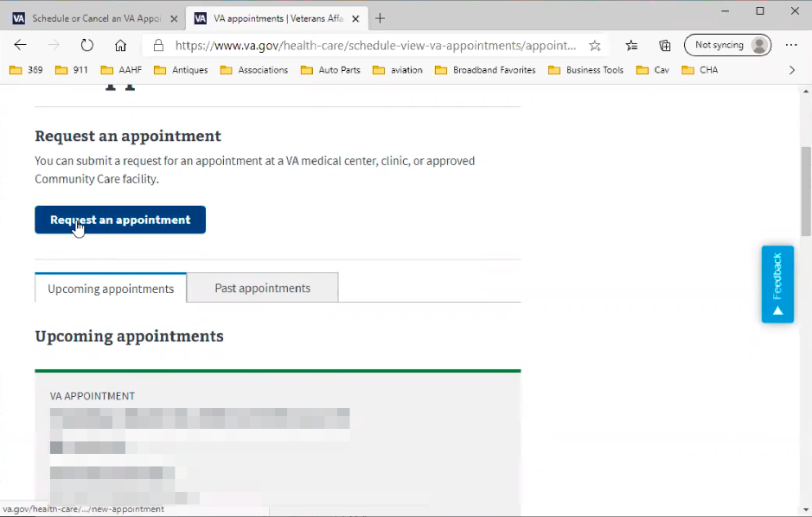

Participant clicks on blue “Request and appointment” button.

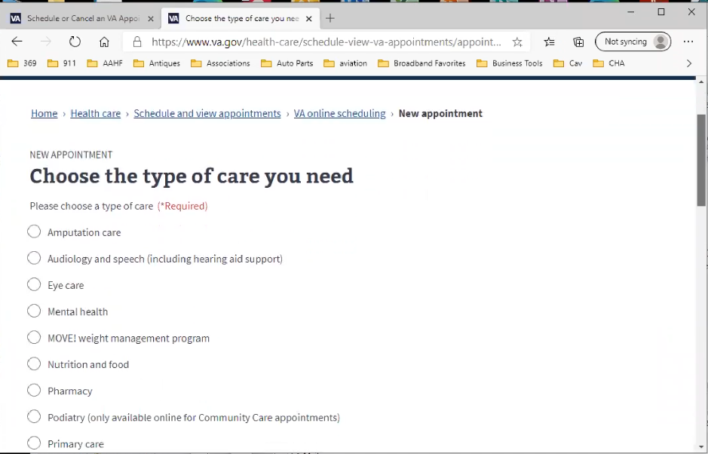Now I am confused on the track that I took.

* **Does the list look familiar:**

Yeah but what I saw before was a drop down. This is a different format. Not the same screen I used.

* **At this point going through that path you just walked us through, where do you think we are now:**

I am also clued into by tab at the top. The VA.gov as opposed to of My Health Vet.

This is their rendition. Apparently they have defaulted to VA.gov.

I don’t know that I can’t use this one but this doesn’t have. *Participant seems to be confused by care options form because they are not custom to his care needs.*

I am guessing there is three things on here that I would have used. Urology. Sleep medicine is on there. Eye care is on there.

* **There is at least one specialty you are not seeing:**

It exists on My Health Vet. Now My Health Vet it is a bit different. You come in and do this first.

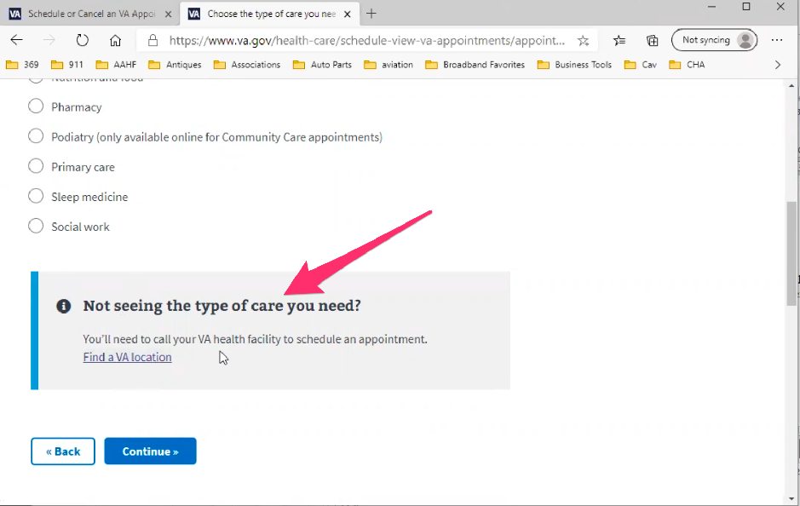

Participant is pointing out the find a VA location info box/callout.

*Participant may be remembering using scheduling tool before it was on* [VA.gov](http://VA.gov) *site? Seems like there could be similar issue of confusion and thinking there are separate tools when Secure Messaging gets ported over.*

Because that's the primary sort. Not all VA locations subscribe to online scheduling. That’s why the Health Vet was set that way.

Where do you think you’re gonna go. That serves well for those that go to the same one all the time. I understand this is the same sock turned inside out for [VA.gov](http://VA.gov). Their just doing it in a different order.

I get both logics. I don’t know one is better than the other. It depends on the user. But I bet if we come in here.

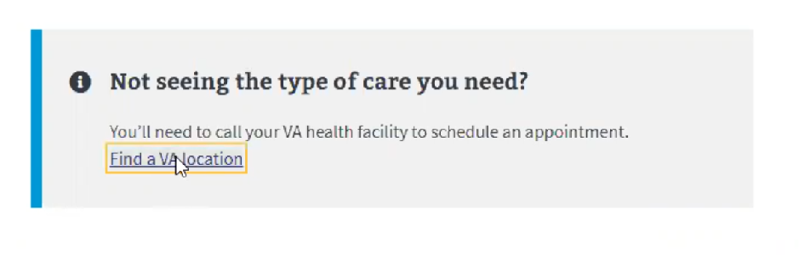

Participant clicks on “Find a VA Location” link in “Not seeing the type of care you need?” info box/callout.

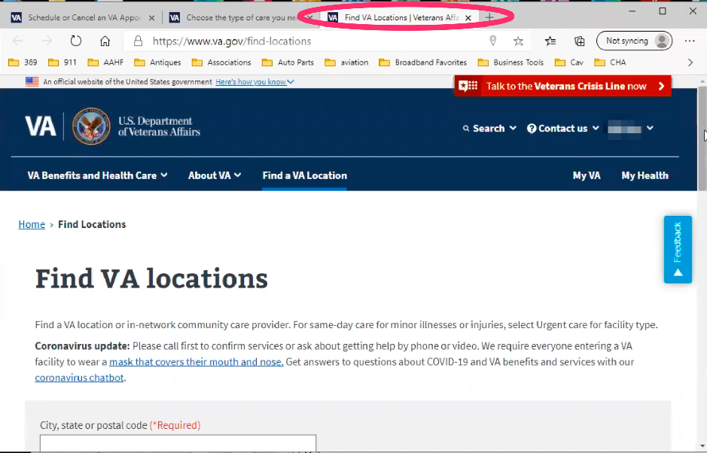

Find VA Location page loads. Participant does not comment that it opens in a new tab.

That’s weird. How did they get that address.

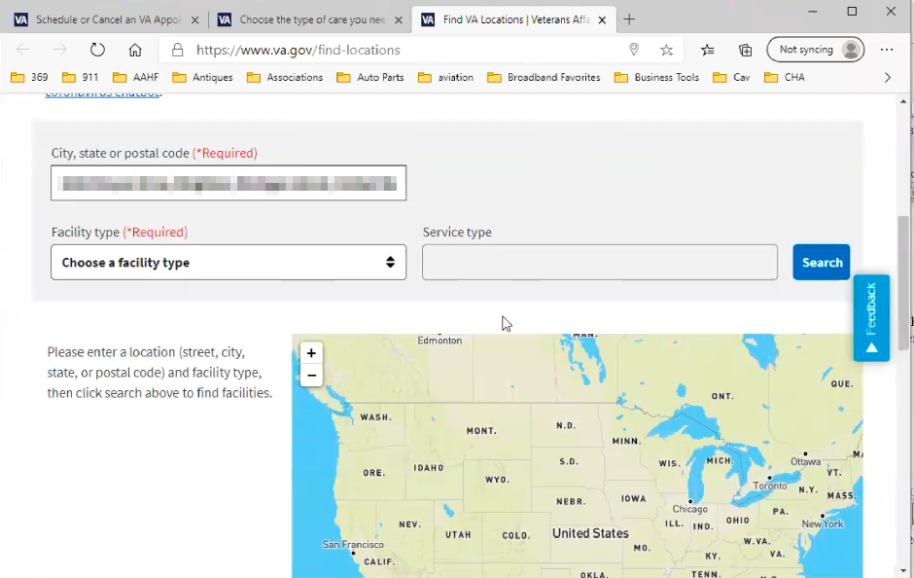

Participant scrolls down page.

**Is that your home address?**

Nope. That is. *Participant changes last digit in street address.*

It was off, but that’s strange.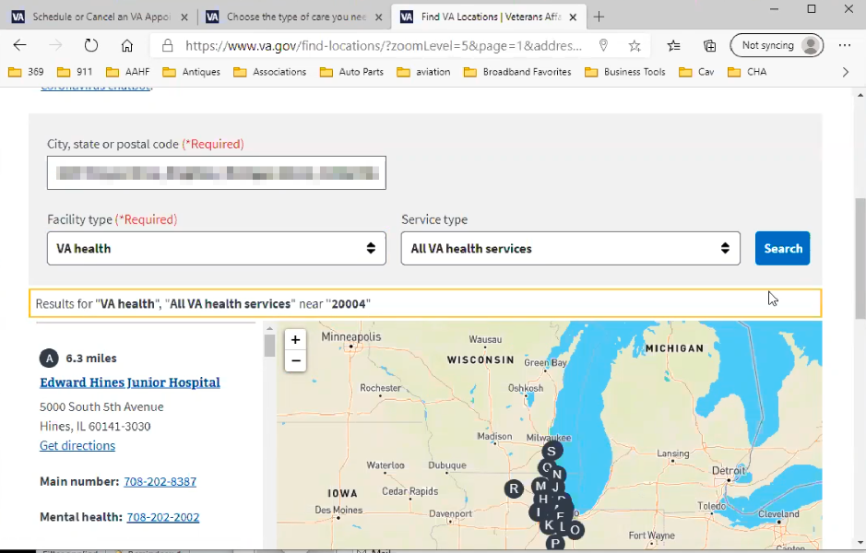

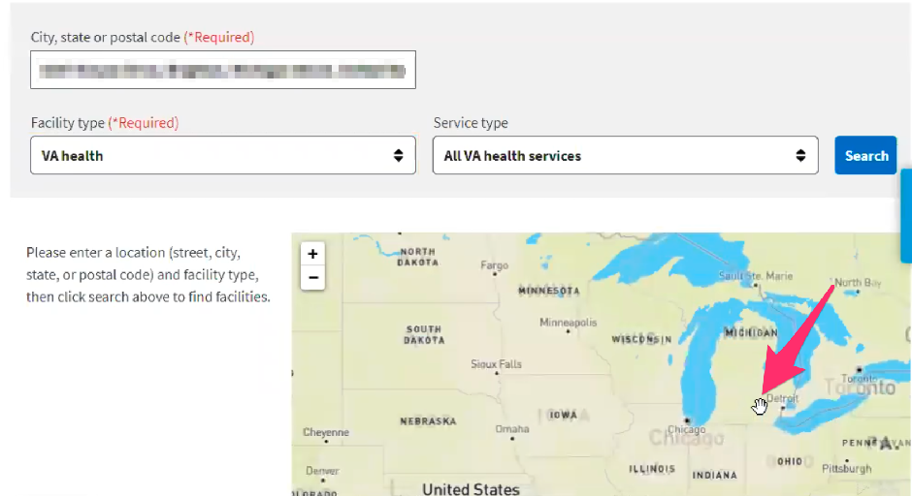

Participant selects VA health from Facility type form field, and “All VA health services” from Service type form field, but does not click on blue “Search” button. Seems to assume the map results will load on field changes.

Participant starts to manually zoom in on US map looking for locations.

Well, that map is pretty. *Participants laughs*. That map is terrible.

Someone needs to right click and find out who designed this one. Look at all the hospitals in Chicago and no where else in the mid-west.

That’s not to helpful, you have me digging up all types of dirt. Thanks.

**My HealtheVet patient portal (15 minutes)**

Let's take a look at My HealtheVet together.

Moderator will ask participant to share screen if not already, or show logged in My HealtheVet account. **(5 minutes)**

1. **What do you wish My Health Vet did that does not exist that you wish was there?**

Yes.

This is a legal issue. I would really like and it I think it would be beneficial if we could find a way to do it. Is on the history that is known and downloadable.

*Participant closes Find VA locations tab. Starts using Edge back button on [VA.gov](http://VA.gov) tab.*

Uh I am just not getting there. *Participant closes* [VA.gov](http://VA.gov) *tab and is back on My HealtheVet tab.*

This might do it. Track health.

It really would be nice if this track health history contained, I understand why this is here. You open this up and I can put in this information. But it be nice to have all appointments under medical events, if that what this means. Otherwise maybe it’s got the wrong category. *Participant seems to be indicating link wording is confusing.*

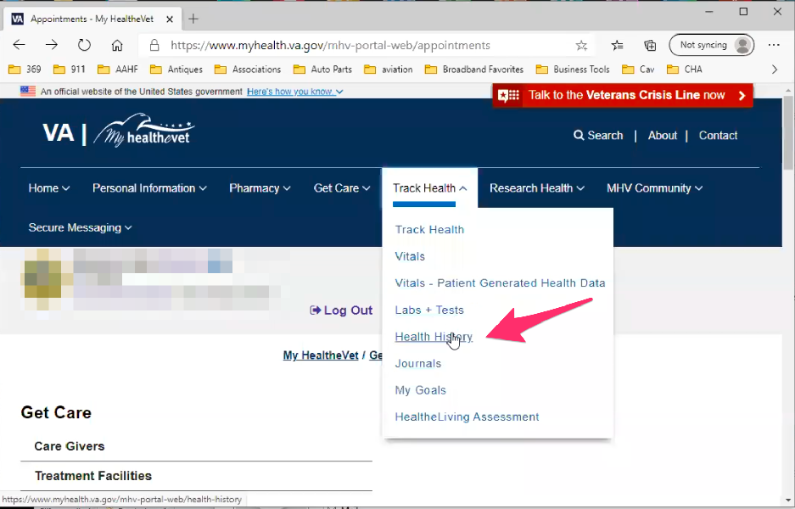

Participant hovers over “Track Health” in main navigation and clicks on “Health History” link in sub menu drop down.

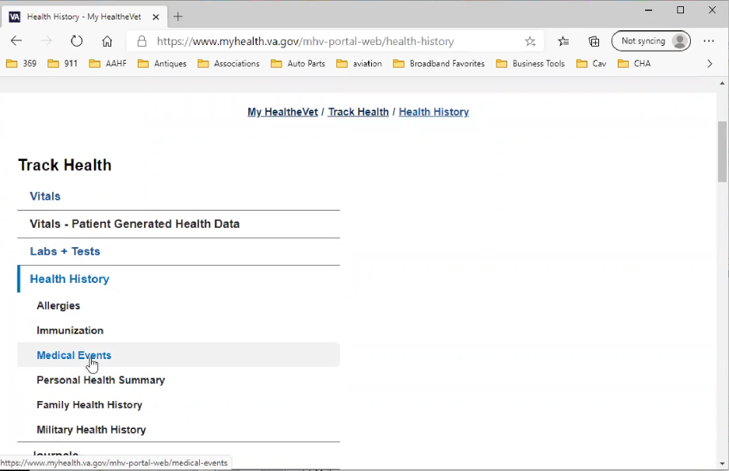

Health History page loads and Participant scrolls down. Participants small browser window seems to be causing an odd layout. The main content is wrapping below the left side navigation. Participant clicks on “Medical Events” link in left sidebar.

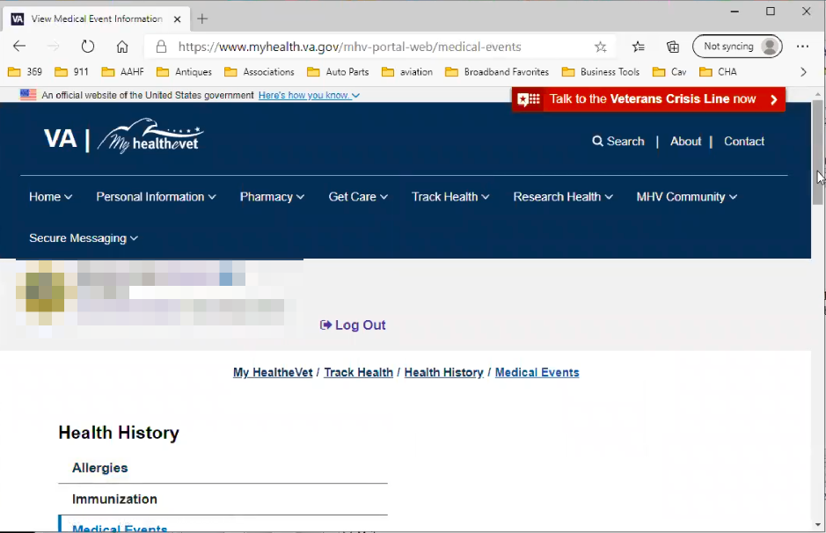

Medical Events page loads. Appointments page loads. Participants small browser window seems to be causing an odd layout. The main content is wrapping below the left side navigation.

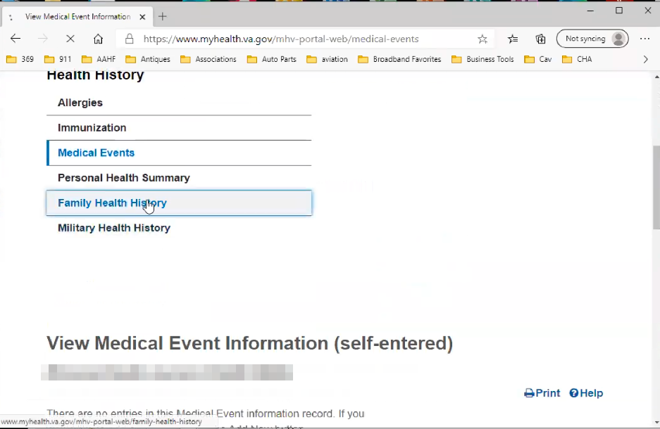

Participant scrolls down Health History page and clicks “Family Health History” in left hand sidebar.

I have filled out a family medical history so it would be nice if that were in there.

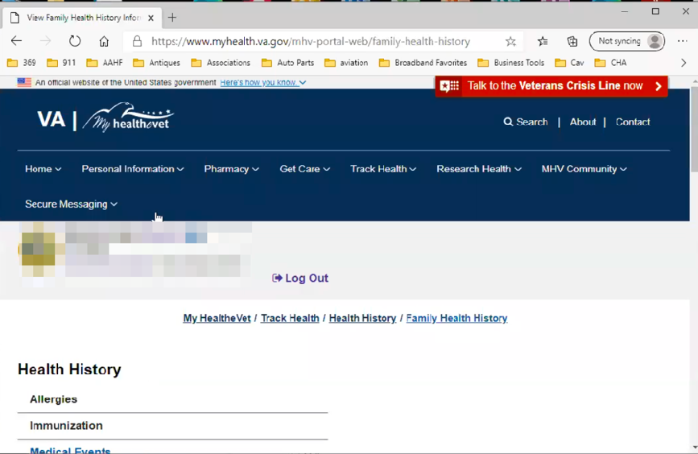

Family Health History page loads and Participant scrolls down. Participants small browser window seems to be causing an odd layout. The main content is wrapping below the left side navigation.

**Having things to bubble up from your official electronic health record**:

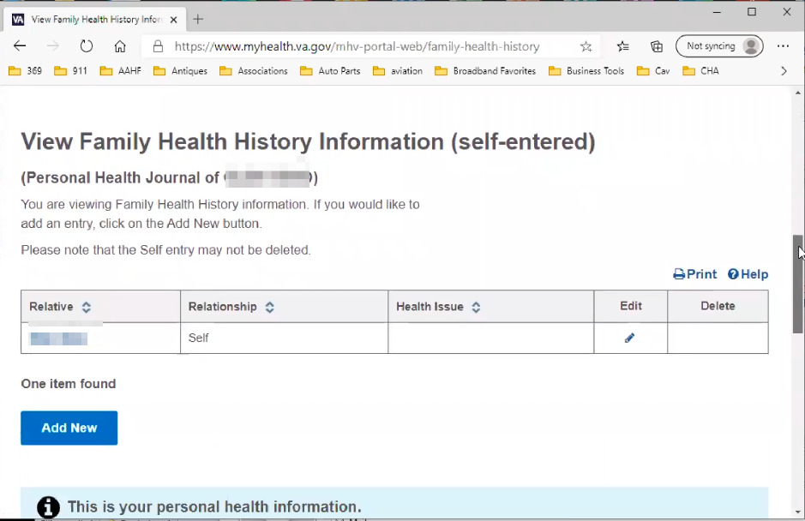

Participant scrolls down to main content of page.

Yes. I know from a security stand point you’d have to go step by step. Yes, upload this information. I want to be able to see that.

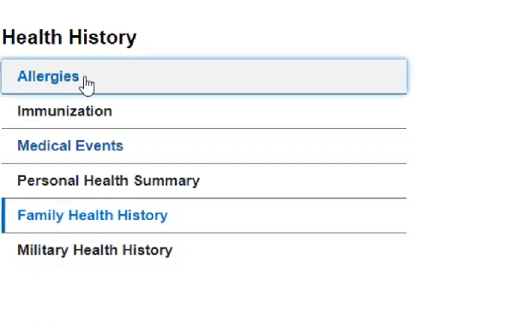

Participant clicks on “Allergies” link in left sidebar menu.

But that is what your password and id is for. *Participant seems to be referring to security around sharing health information in history.*

My allergies, I don’t know how many times I am asked that.

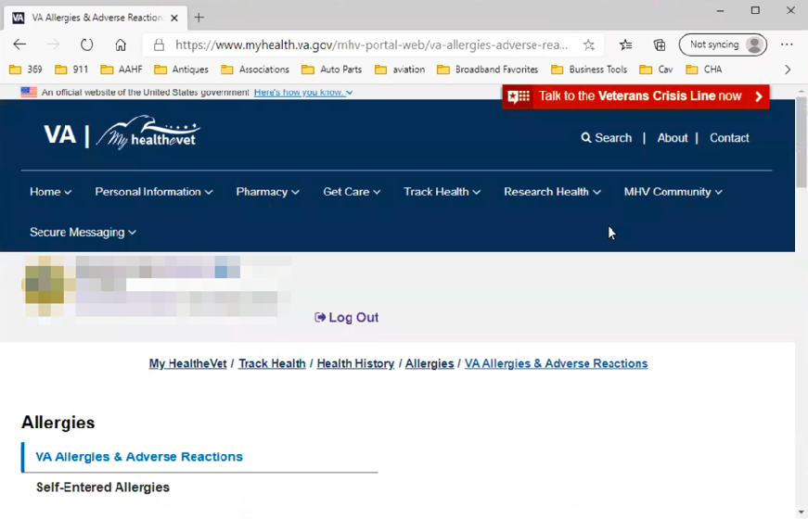

Allergies page loads and Participant scrolls down. Participants small browser window seems to be causing an odd layout. The main content is wrapping below the left side navigation.

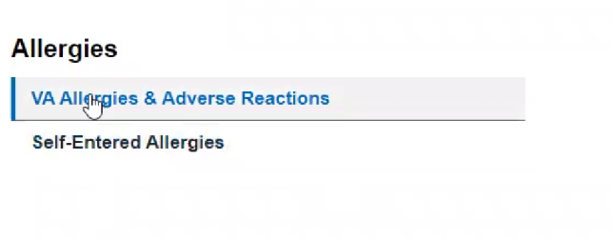

Participant clicks on “VA Allergies & Adverse Reactions” link in left sidebar menu.



VA Allergies & Adverse Reactions page loads and Participant scrolls down. Participants small browser window seems to be causing an odd layout. The main content is wrapping below the left side navigation.

**Seeing it reflected here:**

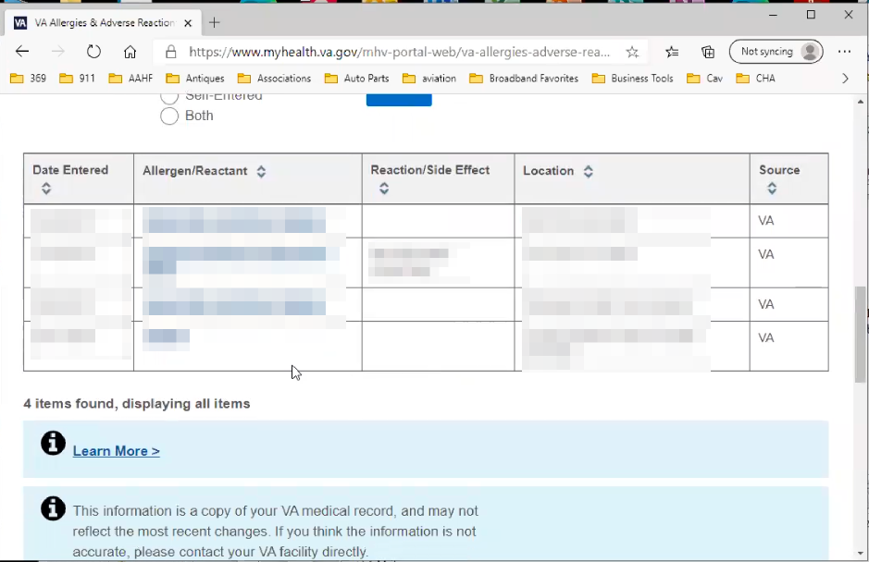

Participant scrolls down page and shows list of allergies.

Guess how many times it has been asked, this one uploads but that’s because I saw doctors at different locations and that’s why it was noted. In all 4 of these situations I had a kidney stone attack or something.

So I don’t know why this is available. This is good. *Participant seem to be referring to VA supplied allergy data.*

Then I don’t need to go in every time and get a data dump from the database. Well, this could take some time. So you need to go there a few times to see if the download came in because it doesn’t send you an alert. That one doesn’t send you a message.

**Thank you and closing (2 minutes)**

Feedback:

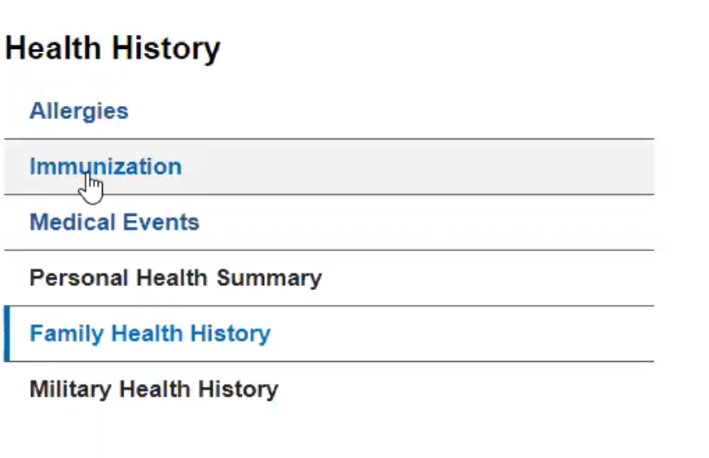

Participant clicks on “Immunization” link in left hand sidebar.

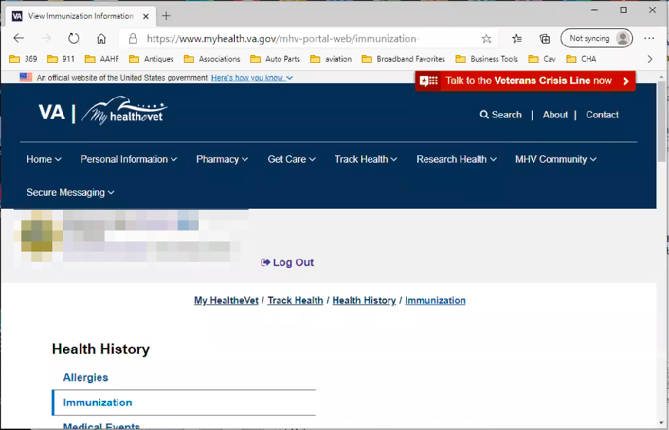

Immunizations page loads and Participant scrolls down. Participants small browser window seems to be causing an odd layout. The main content is wrapping below the left side navigation.

See they should have my immunizations right here.

Instead of them asking me if I had a flu shot. Those guys are supposed to know that. Or if I want to know on the phone. I should be able to look that up. I understand everyone might not want that on there. The capability is there. I am not asking anyone to populate a difference database.

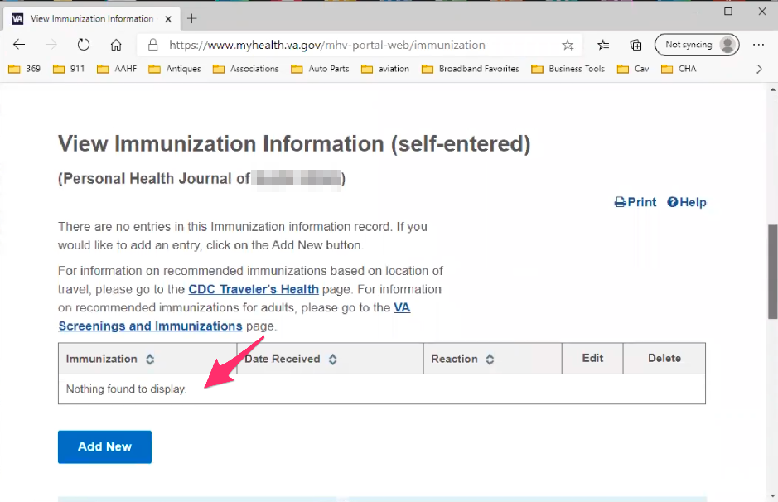

Participant scrolls down the page and points out there is not information in table. Does not seem to notice the title says “View Immunization Information (self-entered)” indicating this is something the Participant needs to do.